|  |
| --- |
|  |
|  |
| Mediterranean Platform on Biodiversity |
| User manual |
| Isabel Pozuelo  Project Manager  isabel.pozuelo@geographica.gs |
|  |

|  |  |
| --- | --- |
|  | Mediterranean Platform Biodiversity    System manual  16/05/2017 |

**Table of content**

01. Presentation

02. Platform functionalities

2.1 Home

2.2 Catalogue

2.3 Create map section

03. Geonetwork

3.1. Users and roles

3.2 Add new metadata

3.3 How to share Metadata

04. Geoserver

4.1 Layer style

05. Data base

5.1 Categories and topics management

5.2 Layers management

5.3 Other dictionaries managements

5.3 Thematic maps management

5.4 Update static pages information

06. Server

6.1 Code

6.2 Backup

6.3 Deploy

# 01. Presentation

The Regional Activity Centre for Specially Protected Areas (RAC/SPA) was established by the Contracting Parties to the Barcelona Convention and its Protocols in order to assist Mediterranean countries in implementing the Protocol concerning Specially Protected Areas and Biological Diversity in the Mediterranean.

RAC/SPA, with the collaboration of the company Geographica, designed and developed the **Mediterranean Biodiversity Platform** (MBP). It is an online tool to inventory, catalog and store data on marine and coastal biodiversity in the Mediterranean, and view them on maps. This platform has been developed by the Specially Protected Areas Regional Activity Centre (SPA/RAC), within the MedKeyHabitats project, with a financial support of the MAVA Foundation.

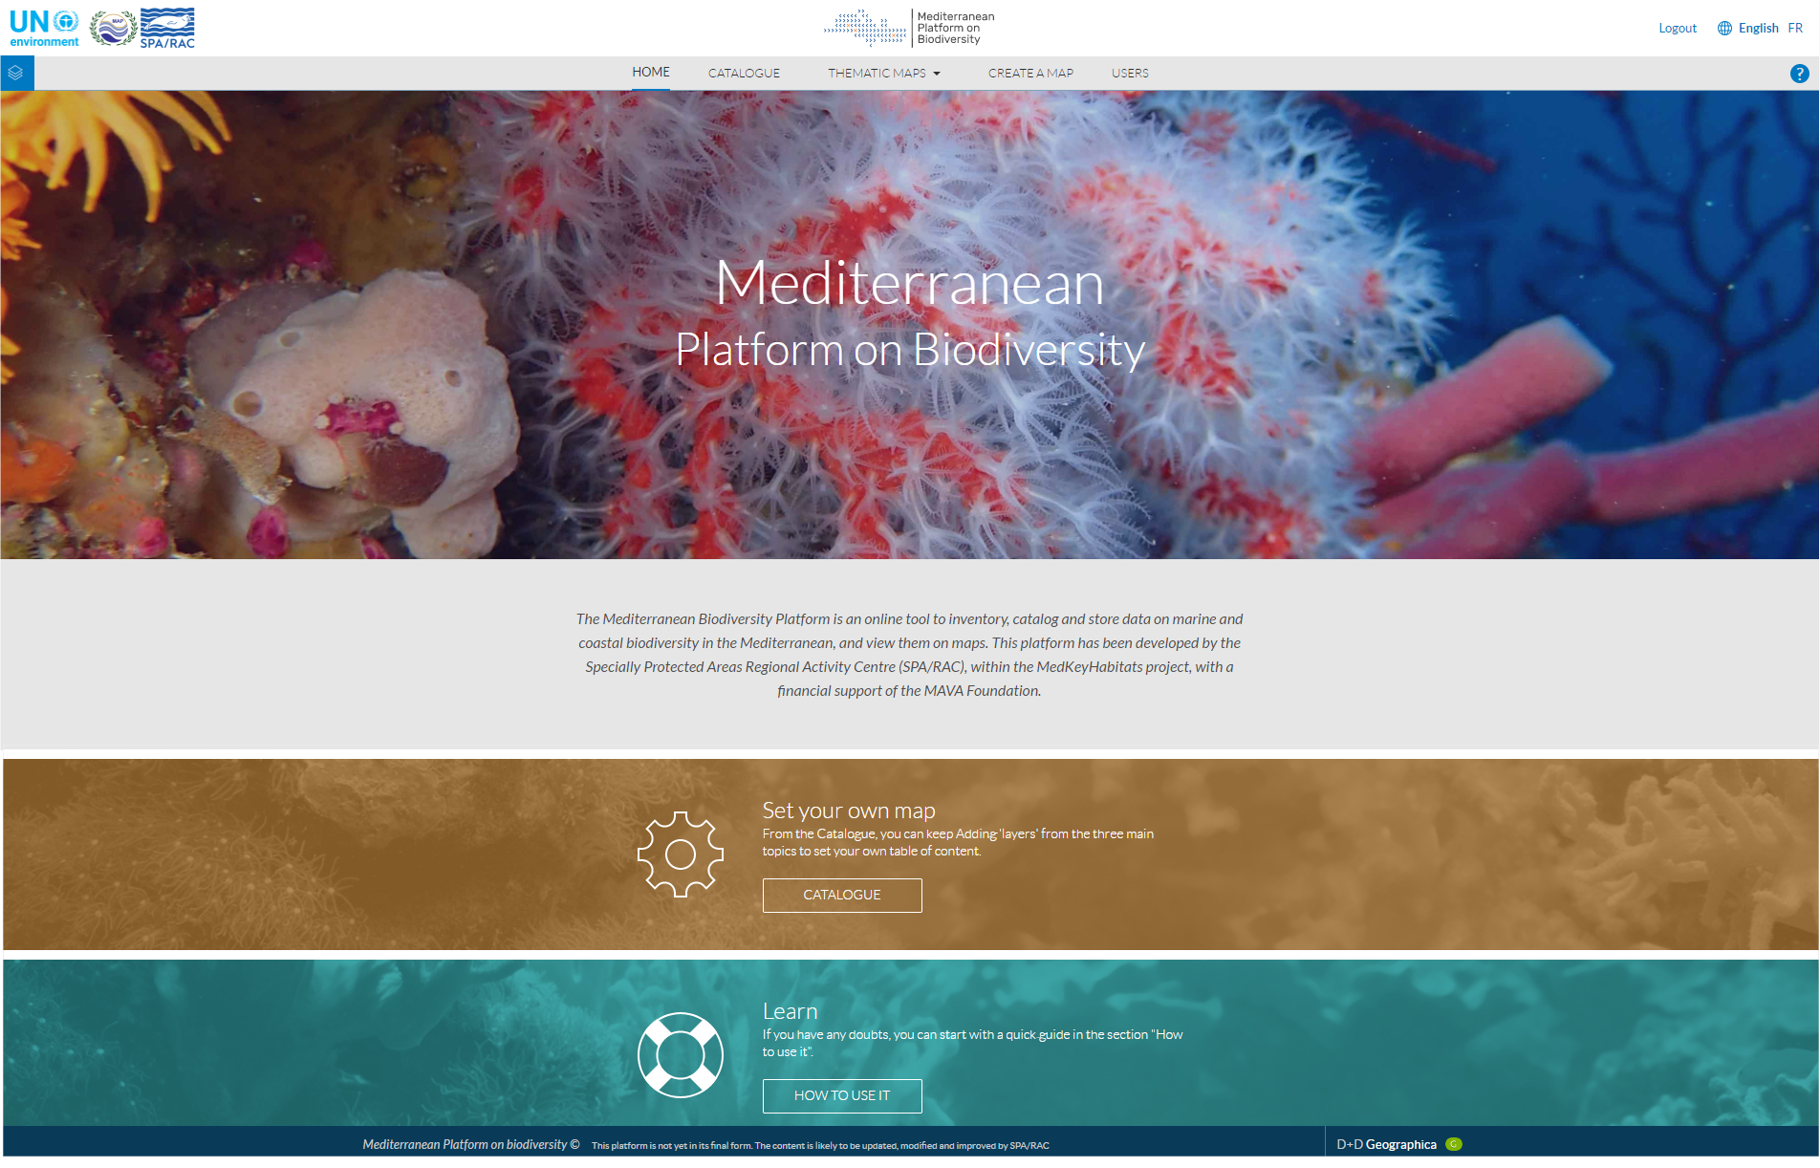

**Case study**

Project: Mediterranean Platform on Biodiversity

URL: <http://data.medchm.net>

# 

### Technology

The MBP system is based in Open Source Technologies.

1. **PostgreSQL/Postgis:** as spatial relational data base.
2. **Geoserver**: as open source server to publish spatial data according to interoperable standards.
3. **Geonetwork**: as open source catalog platform for spatial data. It enables to search, publish and manage metadata.

### User profiles

There are 3 types of user profiles with different access permission.

1. **Administrators**: has access to platform visualization + layer management section + user management section + Geonetwork + Geoserver.
2. **Collaborators:** has access to platform visualization + layer management section + Geonetwork.
3. **Non registered users**: have access to platform visualization + Geonetwork.

RAC/SPA requested Geographica to transfer the code and give instructions on how to update, change and modify the developed software.

**WARNING**: Geographica under no circumstances accepts responsibility for the use, changes or variations that RAC/SPA or third parties may make on the Mediterranean Platform on Biodiversity code, server, database, or any of its components. and for damages that might derive therefrom.

# 

# 

# 

# 02. Platform functionalities

URL: <http://data.medchm.net>

The platform has 6 main sections/menu:

1. Home
2. Catalogue
3. Thematic maps
4. Create map
5. How to use it
6. User management

## 2.1 Home

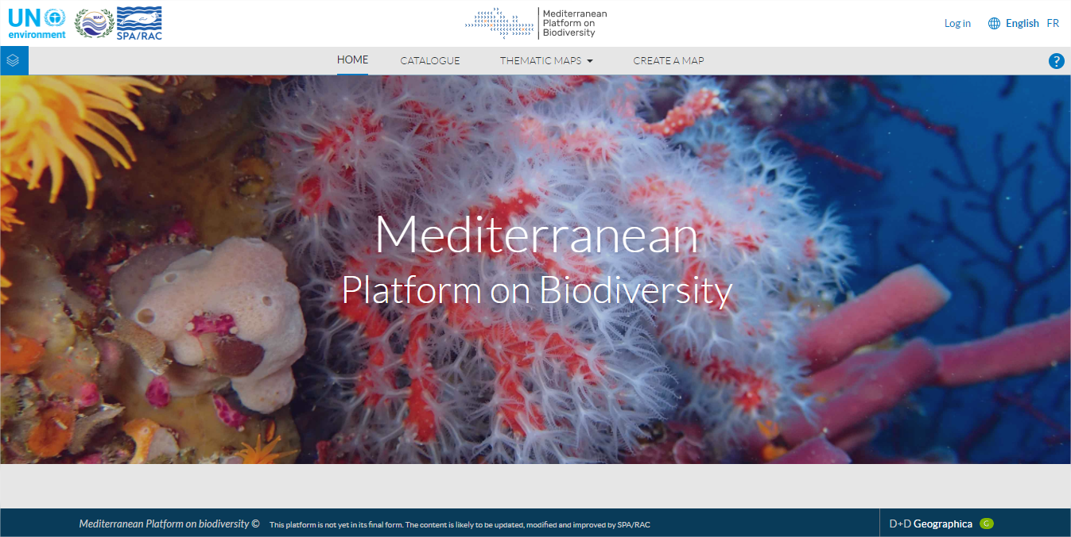

Home page shows a initial information about the project and platform.

Entry to the map is possible via two different pathways:

1. Can be selected by **thematic maps** choosing one of the preconfigured map that shows some of the most important and representative layers of the platform, these layers can also be found across the catalogue.
2. There is also a Manual configuration to visualize the spatial data in the map - see the [catalogue section](http://data.medchm.net/en/catalogue) - which allows all of the spatial information available in the platform to be viewed and added to the map.

## 2.2 Catalogue

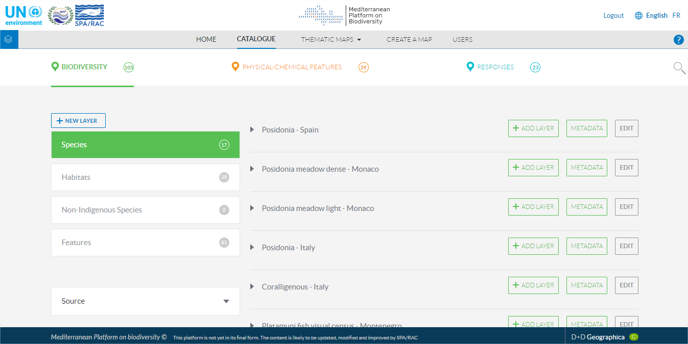

This is the link to a combination of spatial data inventories for the Mediterranean, which are available across the catalogs of different organisations and institutions, with information of interest on the Mediterranean.

The platform is under constant evolving and information will be incorporated progressively from the different institutions in the countries surrounding the Mediterranean Sea.

It is possible to navigate easily and accurately, with information organised into three main categories and their respective subcategories:

**Biodiversity**

**Physical-chemical features**

**Reponses**

Each piece of spatial data can be added to the contents table for, previously, see it on the map - see [create map section](http://data.medchm.net/en/map) -.

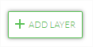

It is possible to access the sheet of detailed metadata and see the description and the source of each service, by clicking on the “deploy icon” The sheets of metadata are normalised according to the established requirements of the European Directive INSPIRE and ISO 19115.

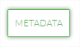

The Search tool allows filtering of the layers to access the data of interest by title, source or description. It also allow an advanced search filtering by Country, MSDF Region or Year.

The spatial data provided are interoperable, allowing connection with the standards set by the Open Geospatial Consortium (OGC) and the INSPIRE directive.

## 

## 

## 2.3 Create map section

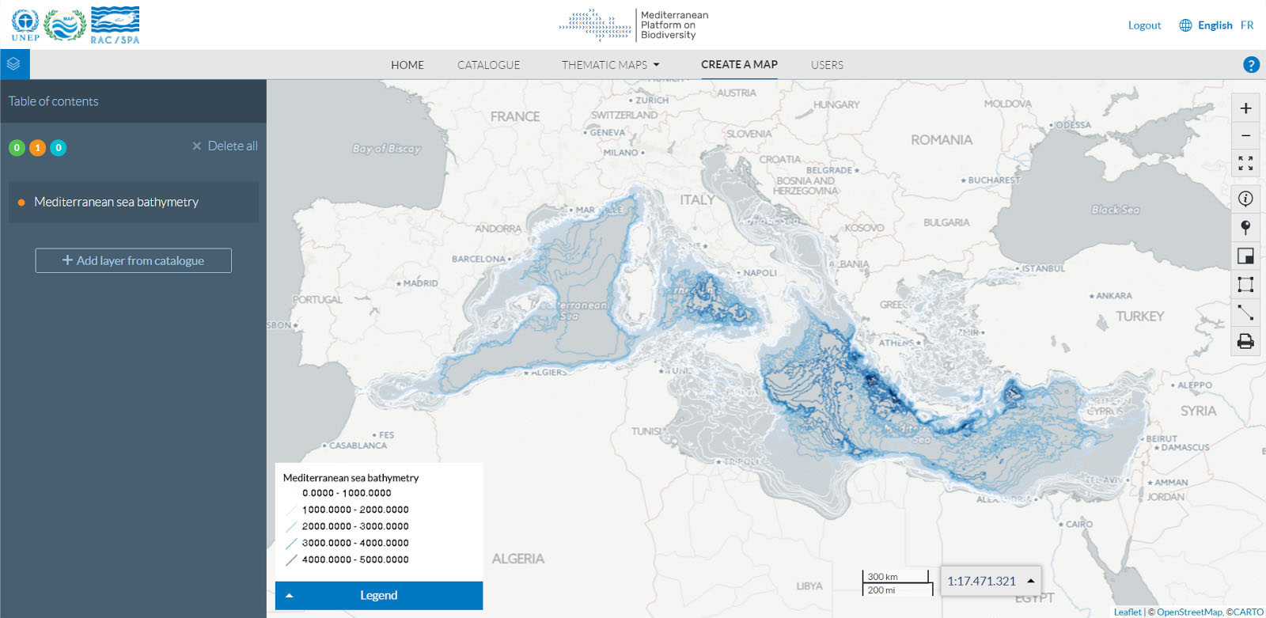

### Table of Contents

Show the catalog layers added to the map in the top left hand corner. Allow:

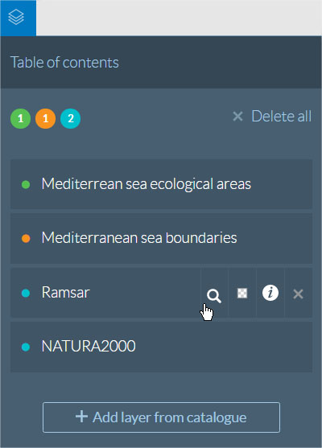

1. Activate or disactivate the visibility of a layer on the map by clicking on it.
2. See the description by clicking on the information icon 
3. Zoom into the layer extent by clicking on the magnifier icon 
4. Change the brightness , This is most useful when you would like to view various layers simultaneously 
5. Eliminate layers from the contents table by clicking on 
6. Access the catalogue - view [catalogue section](http://data.medchm.net/en/catalogue) -.

### 

### Map tools

* **Base map:** You can choose the Base map that you want to display in the background of the map: Bing satellite, Positron Carto, Natural Earth, Esri or OpenStreetMap.  
    
  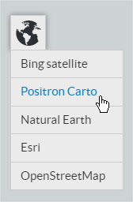
* **Legend:** By clicking in the Legend button you can consult the legend which shows the symbology which represent all the objects and layers in the map.  
    
  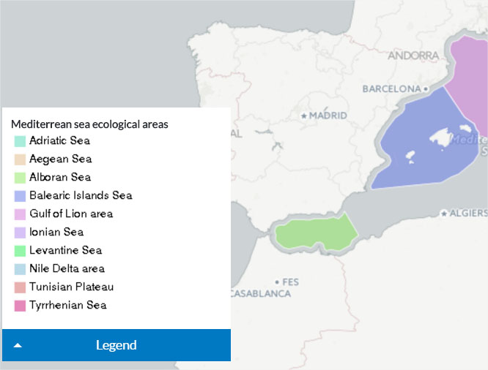
* **Navigation tools:** It is possible to navigate through the map by dragging, making zoom with your mouse scroll wheel or by clicking in the navigation icons. To make more/less zoom or establish the initial extent.  
    
  
* **Identification on the map:** It is possible to identify the spatial objects and consult the attributes by clicking on the “Feature info” icon and then click in the map object.  
    
  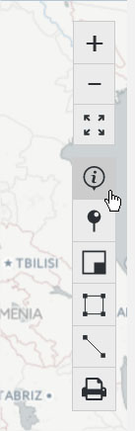
* **Get coordinates:** It is possible to get a point coordinates (latitude and longitude) by clicking in the Get coordinates icon and then select a specific location.  
  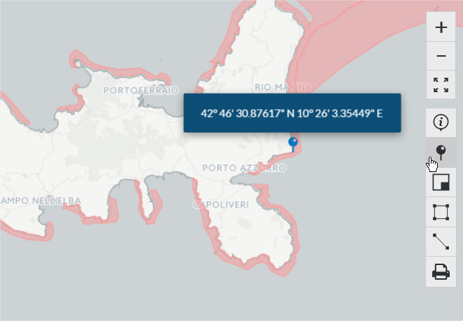
* **Overview map:** It is possible show and hide the overview map that defines the boundaries of the main map by clicking on the icon.  
    
  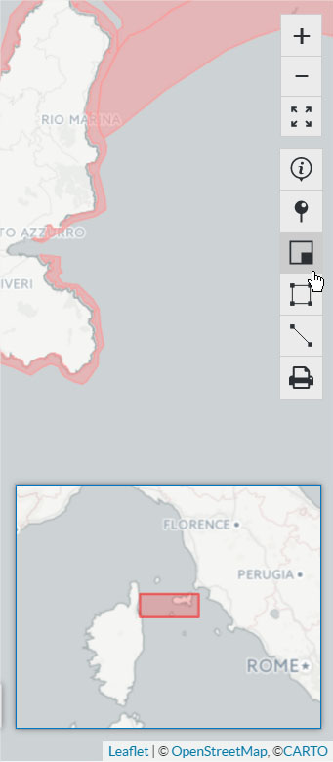
* **Measuring areas and distances:** Using the “measuring areas” and “measuring distance” tool you can draw an area or line and get it surface or distance.  
  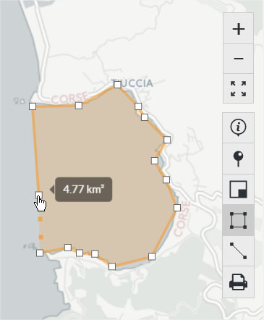
* **Print map:** The print icon enables to download a PDF file with the layers that you are currently visualizing in the Mediterranean Platform on Biodiversity. You can choose between Landscape or Portrait map and include a Title and Description.  
  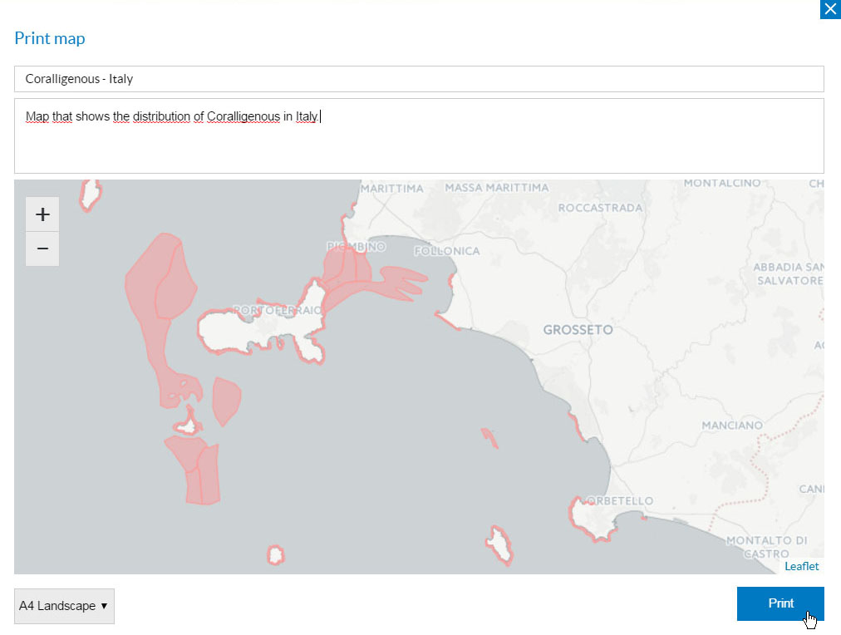

# 

# 

# 

# 

# 03. Geonetwork

URL: <http://tomcat.medchm.net/geonetwork>

## 3.1. Users and roles

There is 3 types of users:

**1. Non registered users:** they can visualize metadata. Any user from the MBP platform can consult metadata without login into Geonetwork.

**2. global_admin:** Has access to:

* **Admin console**, to manage:
  + Metadata and templates
  + Classification systems,
  + Geonetwork settings,
  + Tools
  + Users and groups

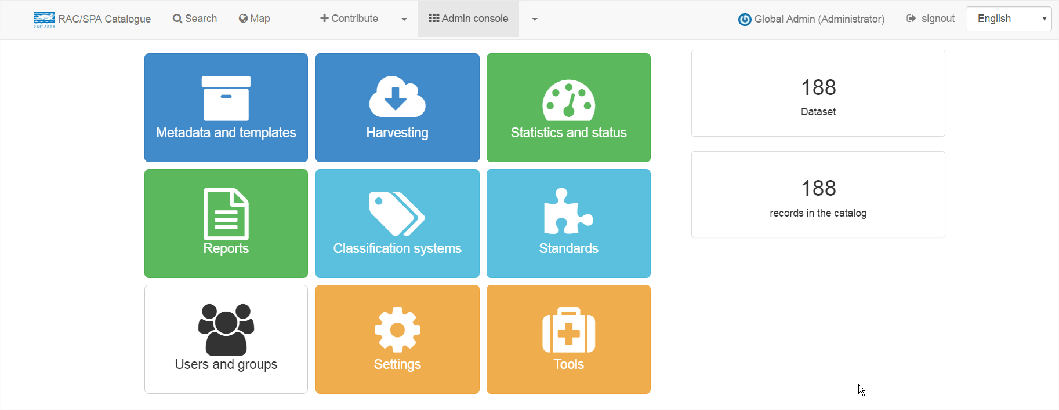

* **Contribute,** to manage all existing metadata and templates.

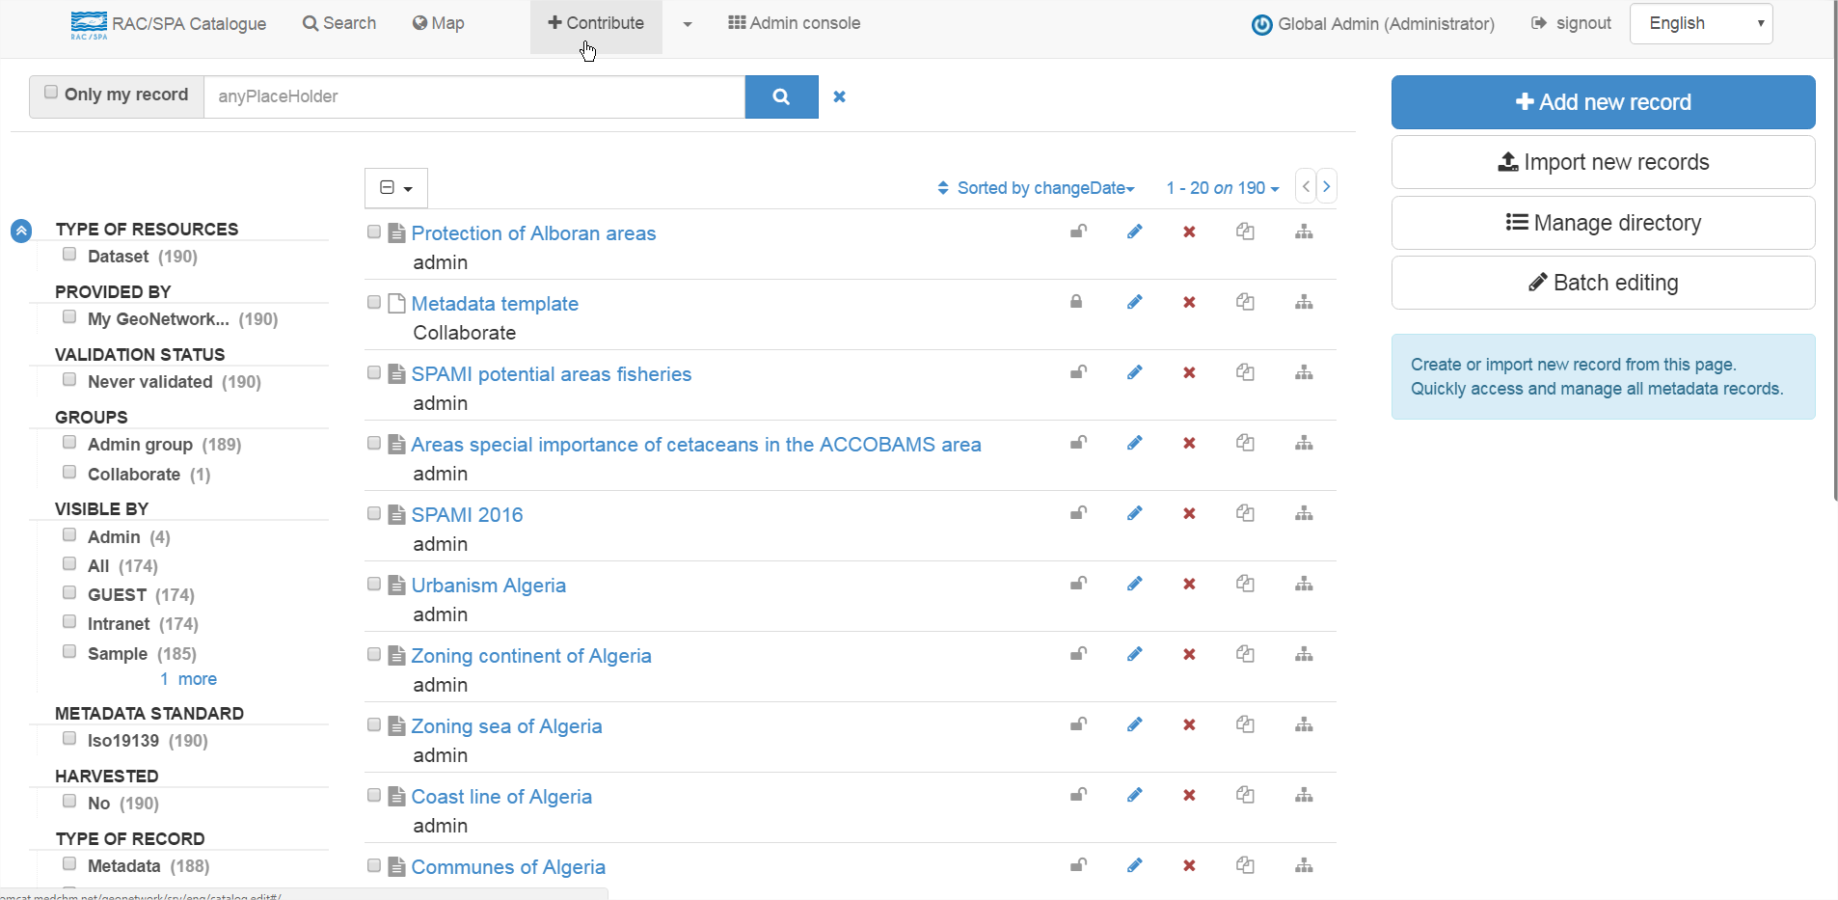

**3. collaborate:** Has access to:

* **Contribute**: This user can not edit existing metadata. He can only edit their own metadata and templates.

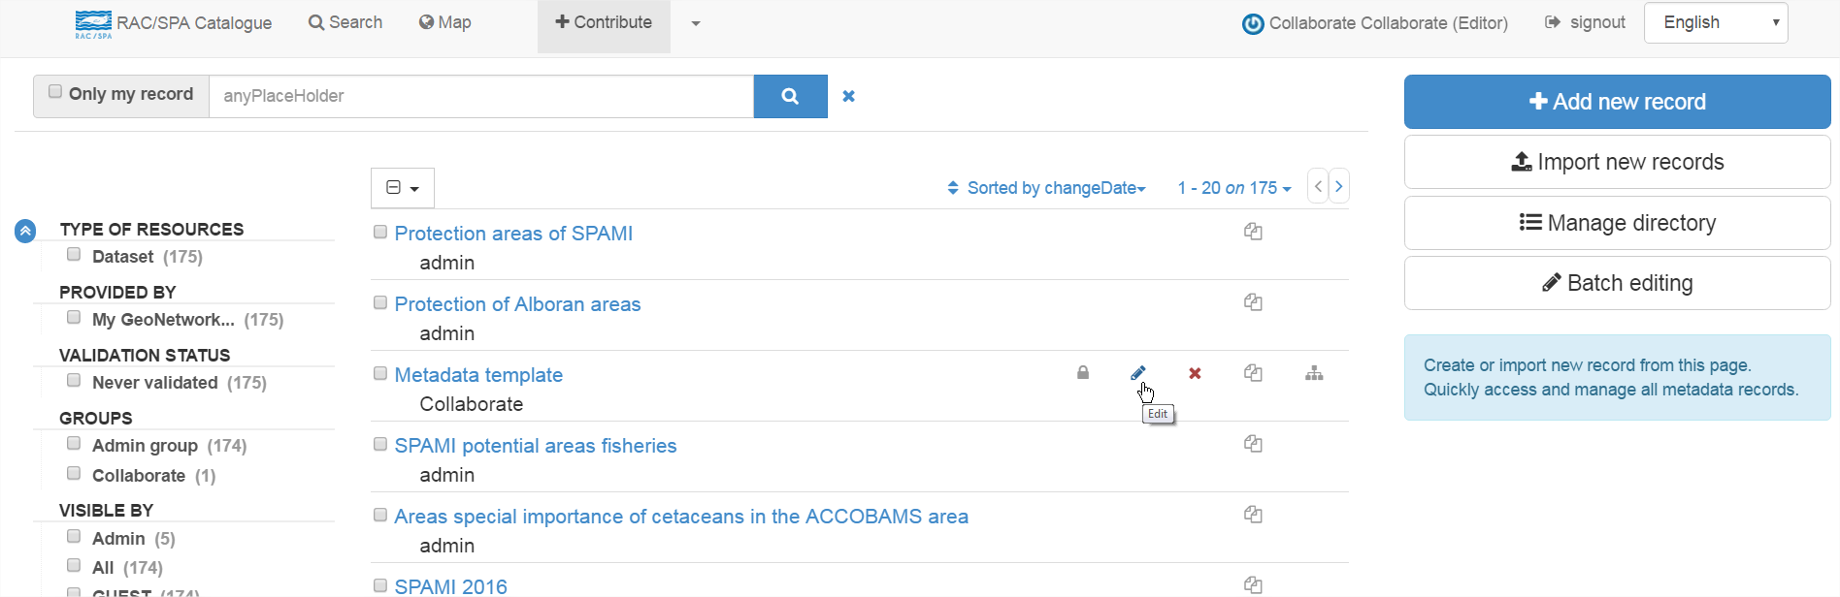  
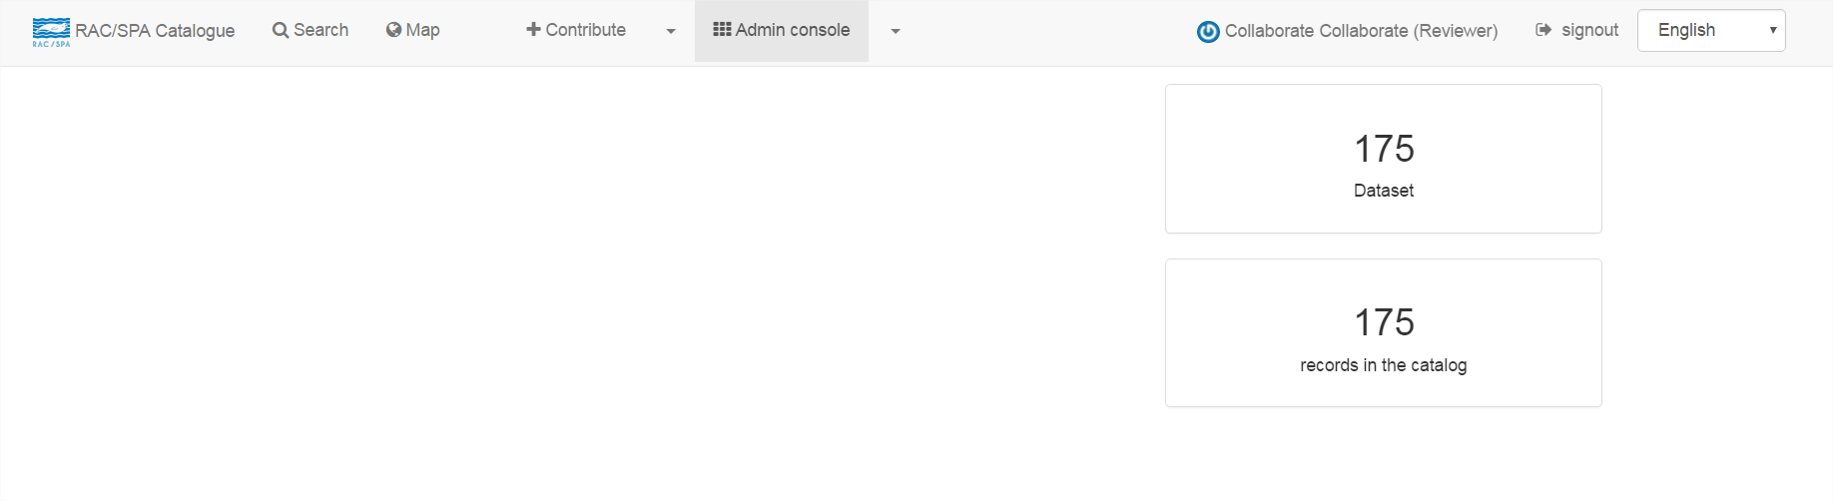  
In the image, you can see how “collaborate” user can’t access to the the Admin console. They can’t either Edit admin metadata and templates. They can only edit their own metadata and templates.

## 3.2 Add new metadata

**Step 1.**

1. Click: Contribute
2. Click: Add new record

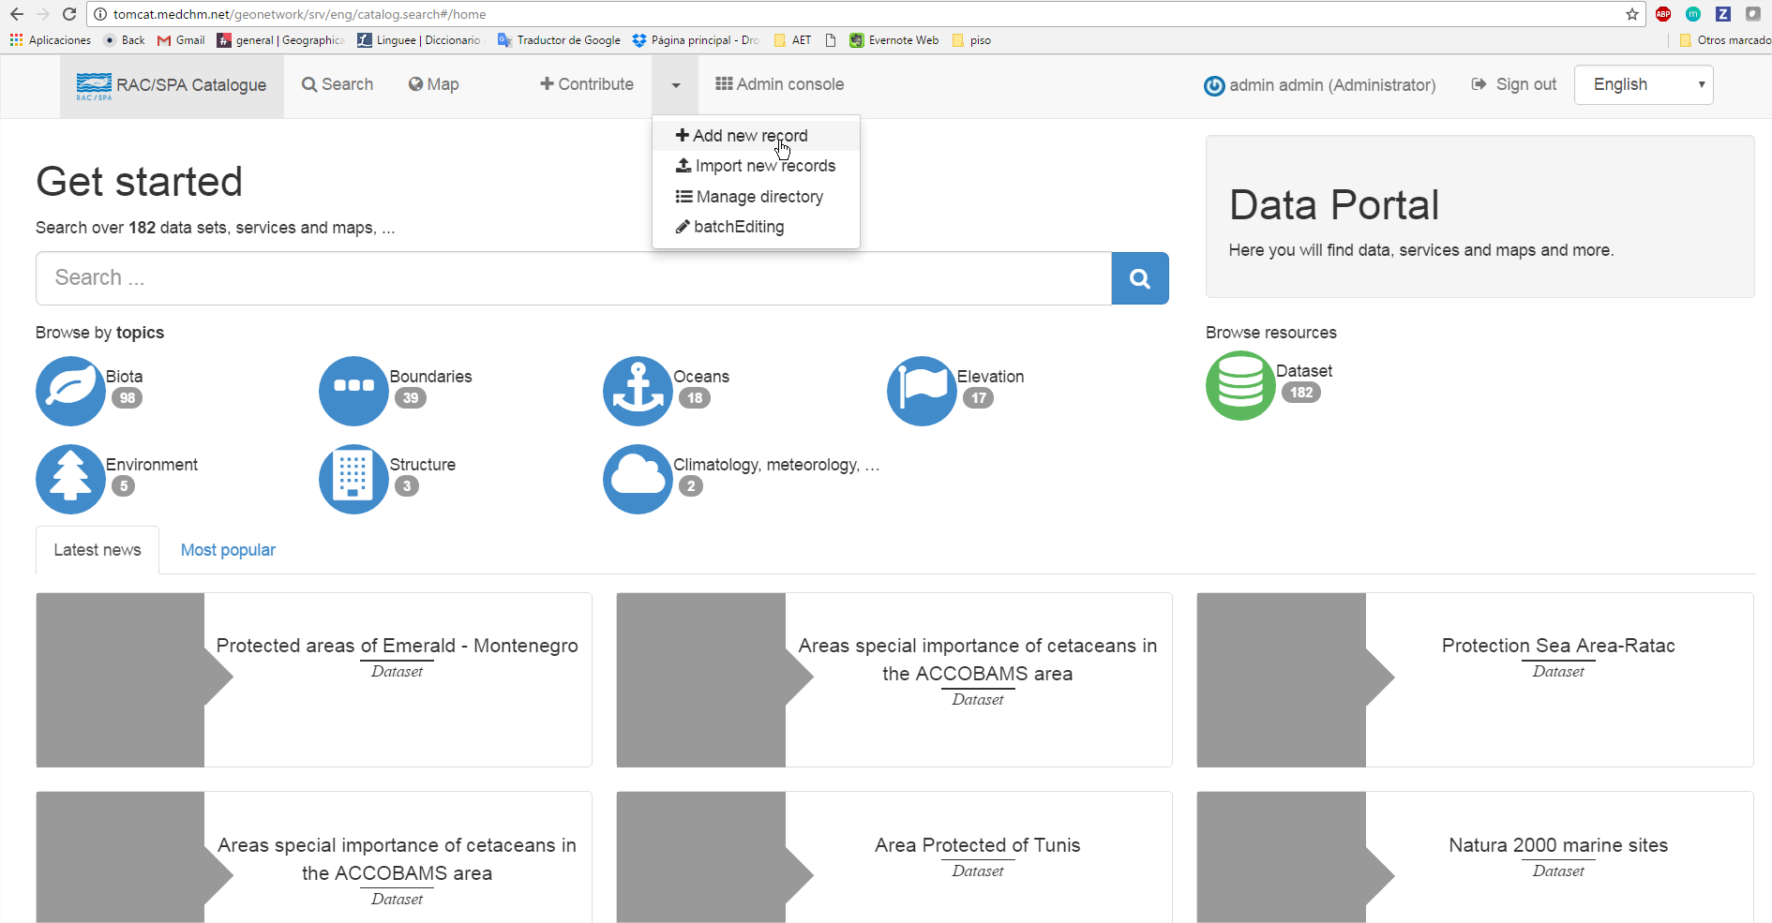  
<http://tomcat.medchm.net/geonetwork/srv/eng/catalog.edit#/create>

**Step 2.** Choose the Metadata Template

1. Click: Metadata template
2. Click: + Create

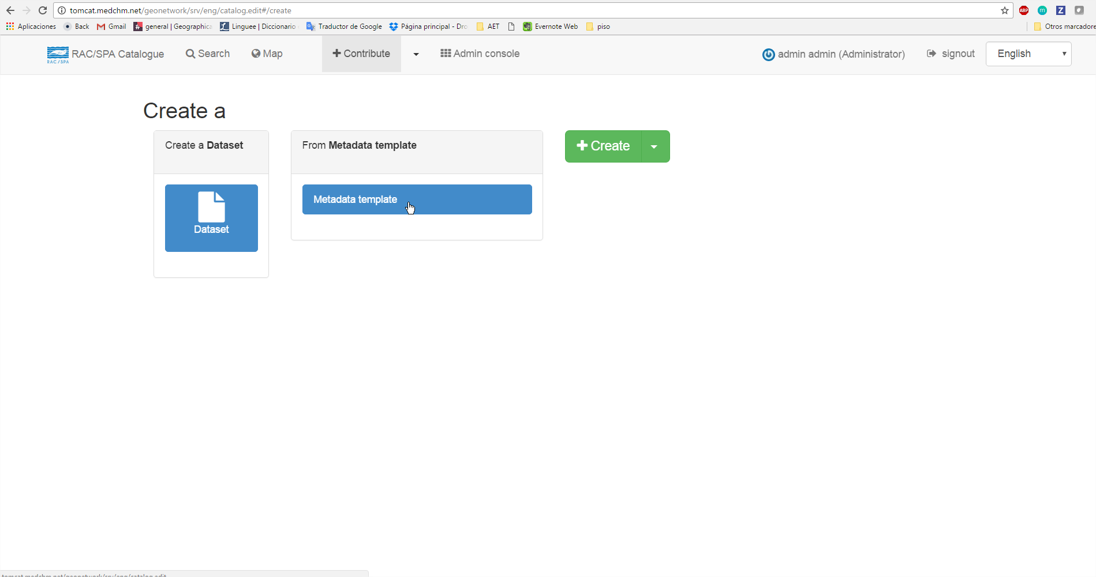

**Step 4.** Full fill the metadata sheet

1. Click: Full view (this enable all the INSPIRE required fields).  
     
   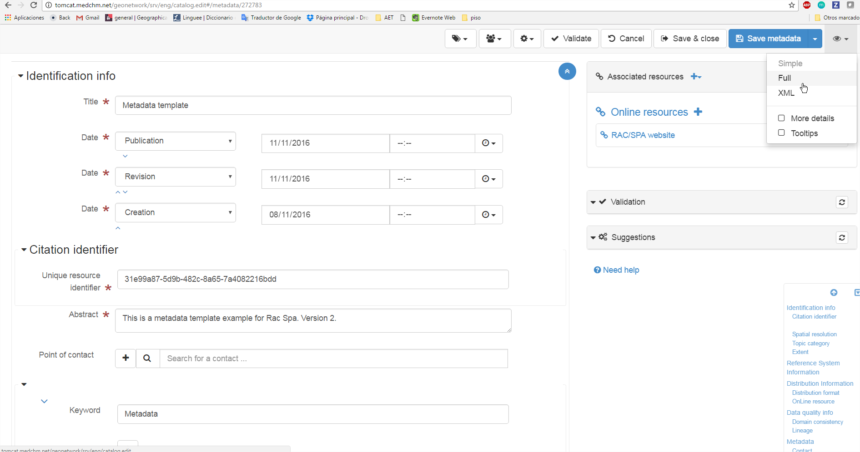
2. In the right side of the screen you can check each section’s index.  
     
   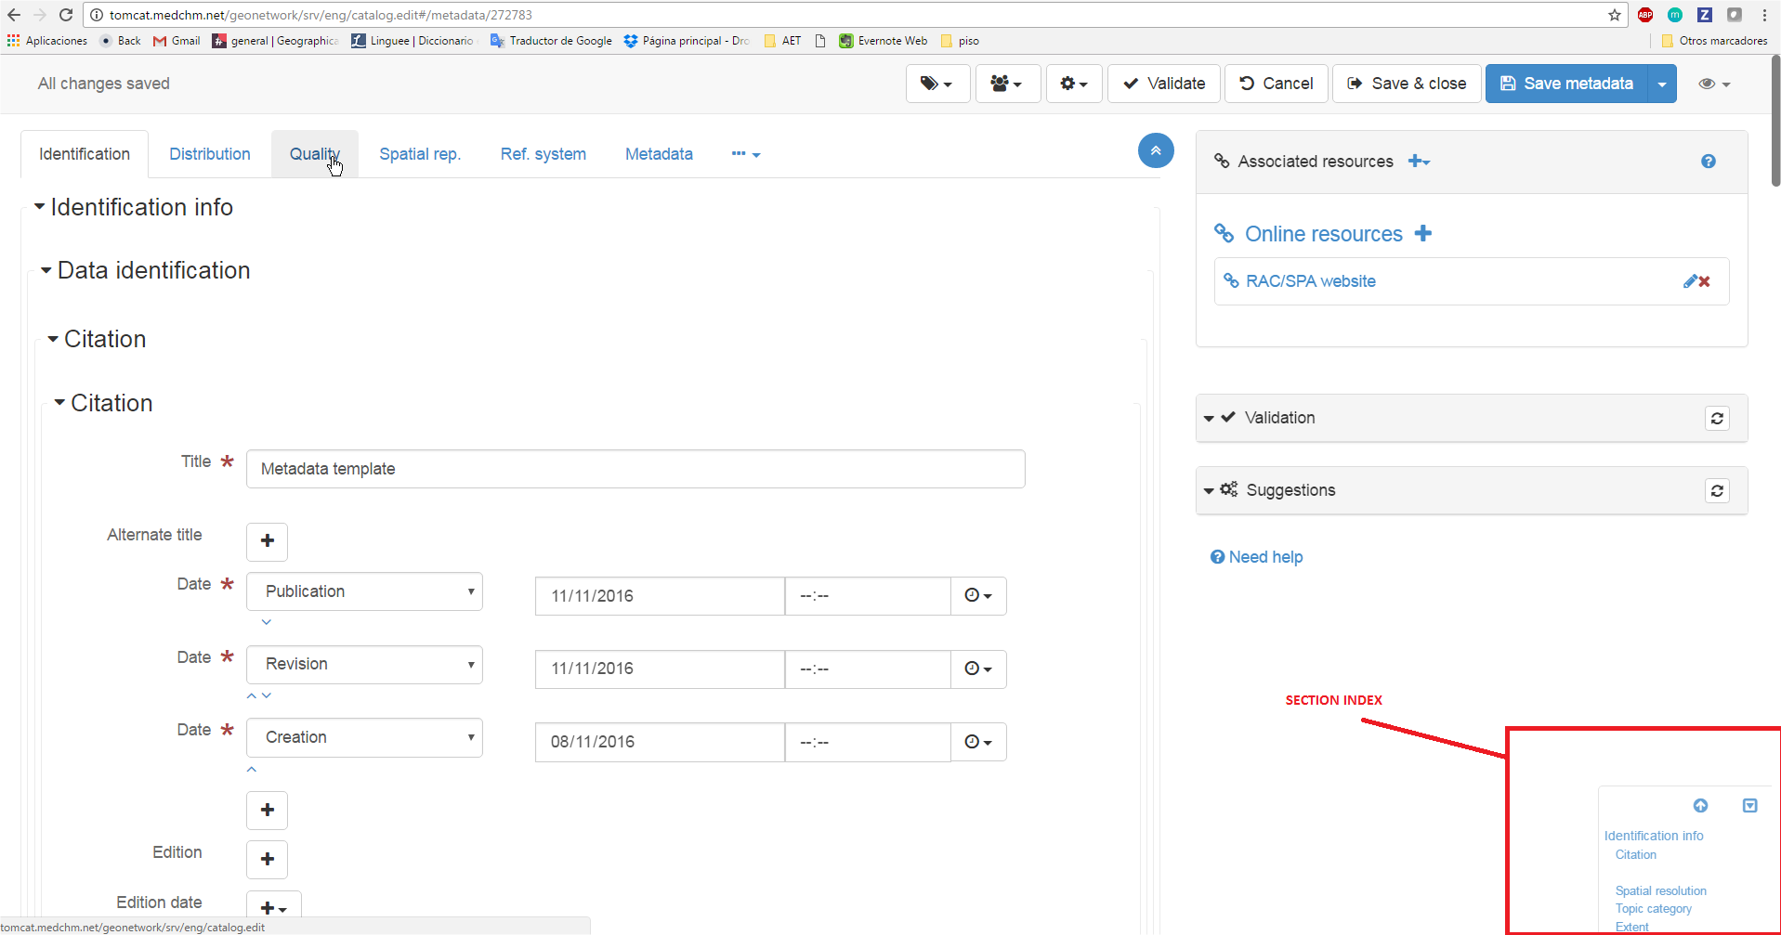

**Step 5**. Save and close:

Once you have completed the sheet, you can Save and Close the metadata sheet. We do not recommend to press the Validate button. It could give some errors if some data are missing, for example if you are not able to provide all INSPIRE fields (which is the most common escenario).

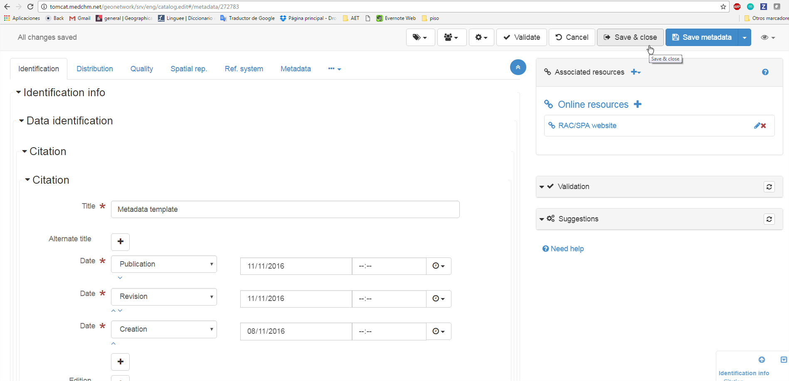

**Step 6.** Privileges

Once you have created new metadata, you have to change the access privileges to make your metadata “Public”, so non registered users can visualize metadata.

1. Click in the “Contribute” menu
2. Look for your resource and click in the “Privilege” icon  
   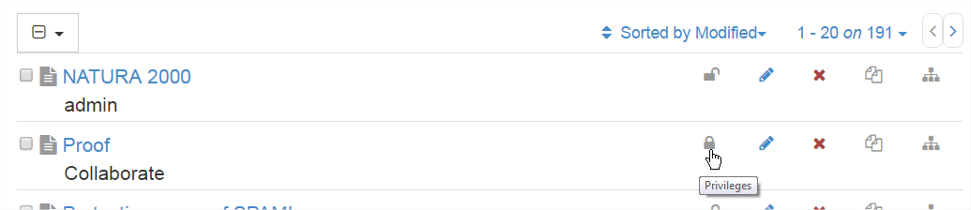
3. Set all privilege, so all users have access to the new metadata (only Admin will be able to edit the new metadata).  
   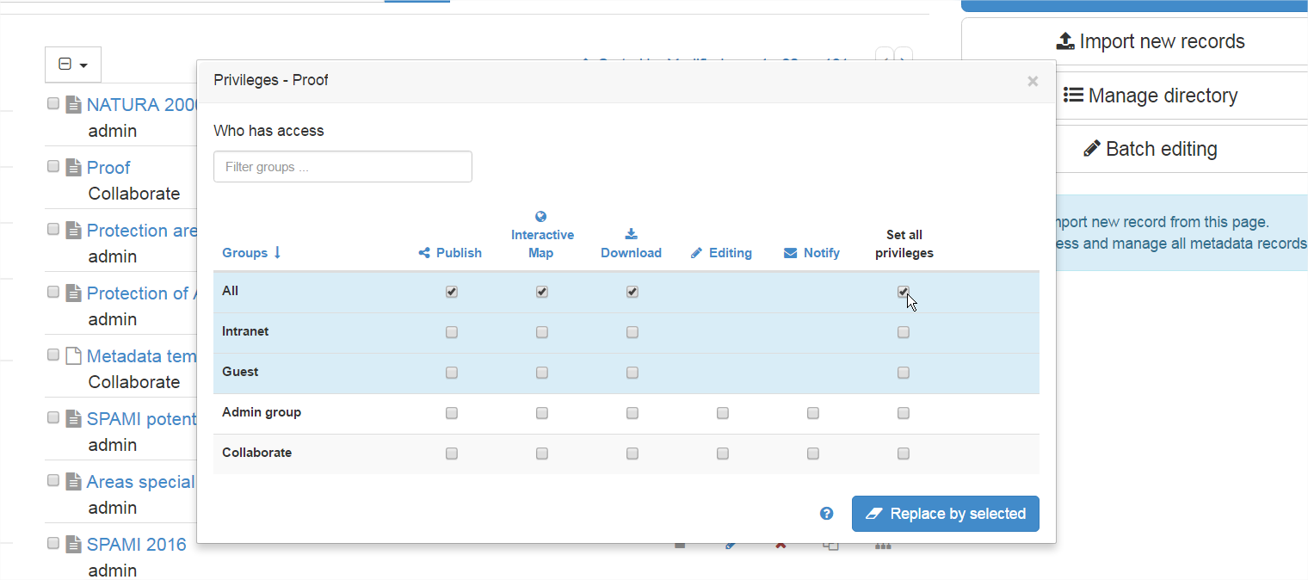

## 3.3 How to share Metadata

You can share it with 3 options:

### Option 1. Plain text file

When downloading the Metadata File, you can get a plain text file. The main advantage of this option is that other organizations can use the metadata using other applications and it can be interpreted and viewed using other interoperable metadata templates. This option is available in the “**Download metadata**” option.

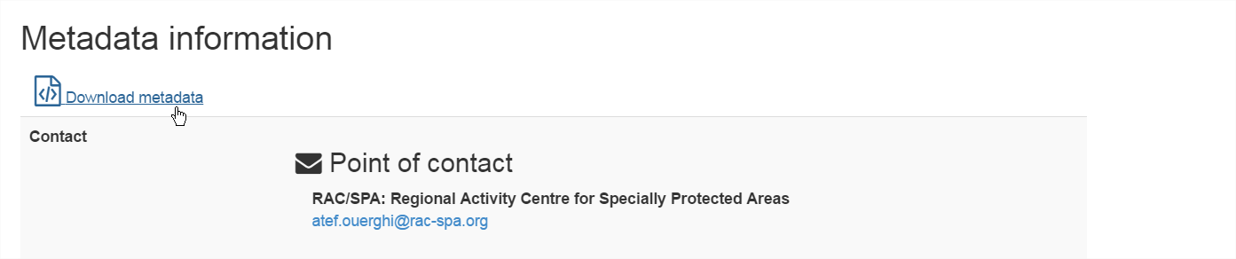

Most web navigator open the file in a new tab, so you can press Right click + Save as to save the HTML file in your computer.

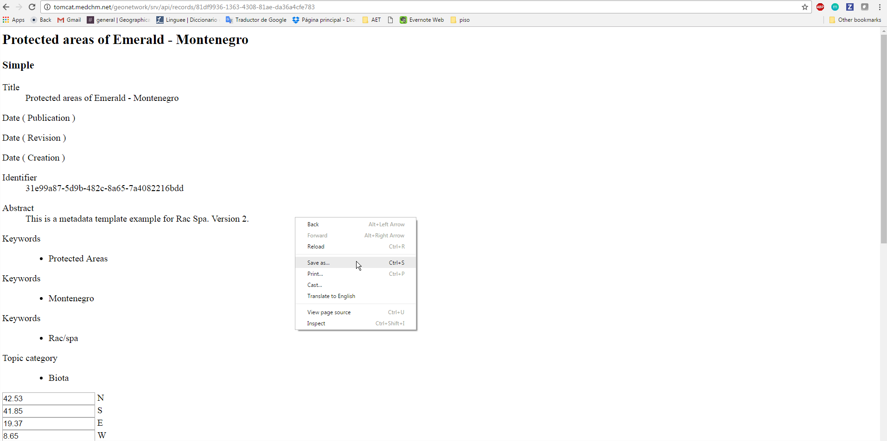

### Option 2. Styled sheet

You can share the metadata sheet by directly sharing the link or you can “Export” the web page: Right click + Save as + Webpage, Complete

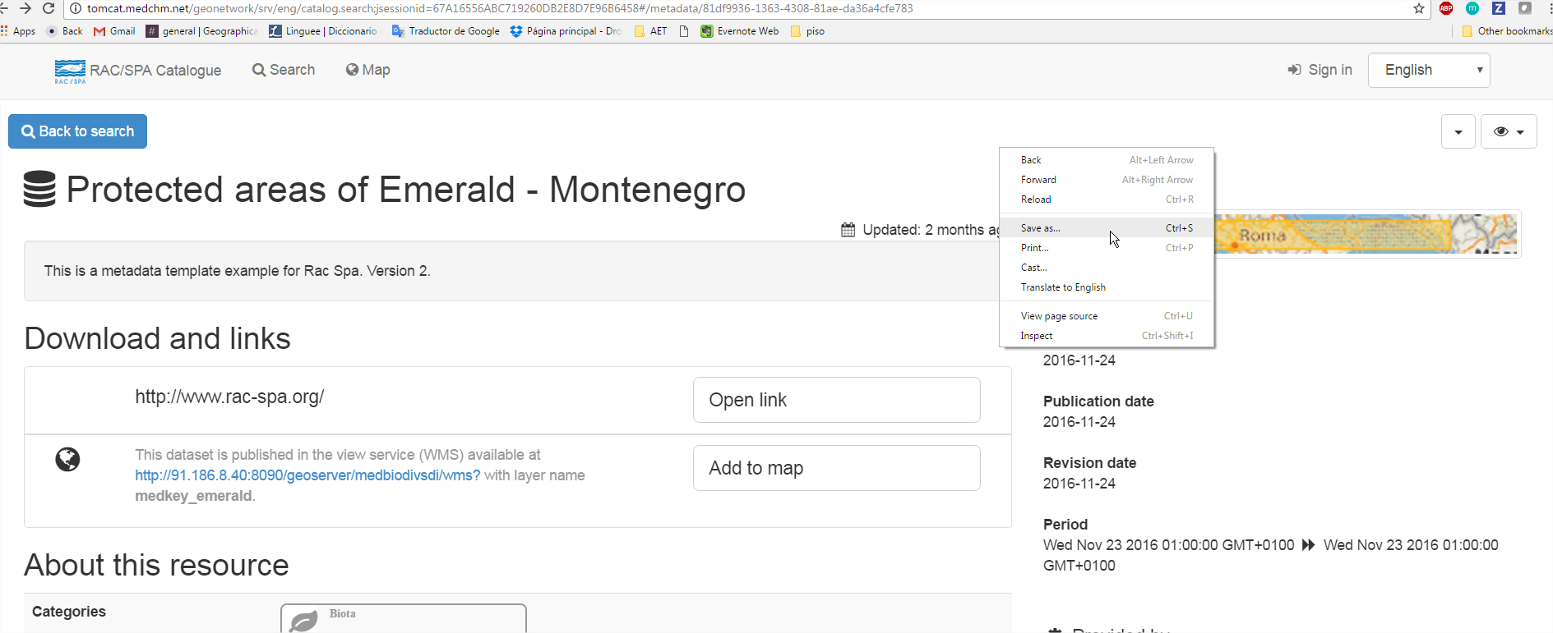

### Option 3. Share Metadata URL

1. Click in the “See more” button.
2. Click in the “Permalink” option
3. You can copy and paste the URL of the metadata. Any user will be able to visualize the resource.

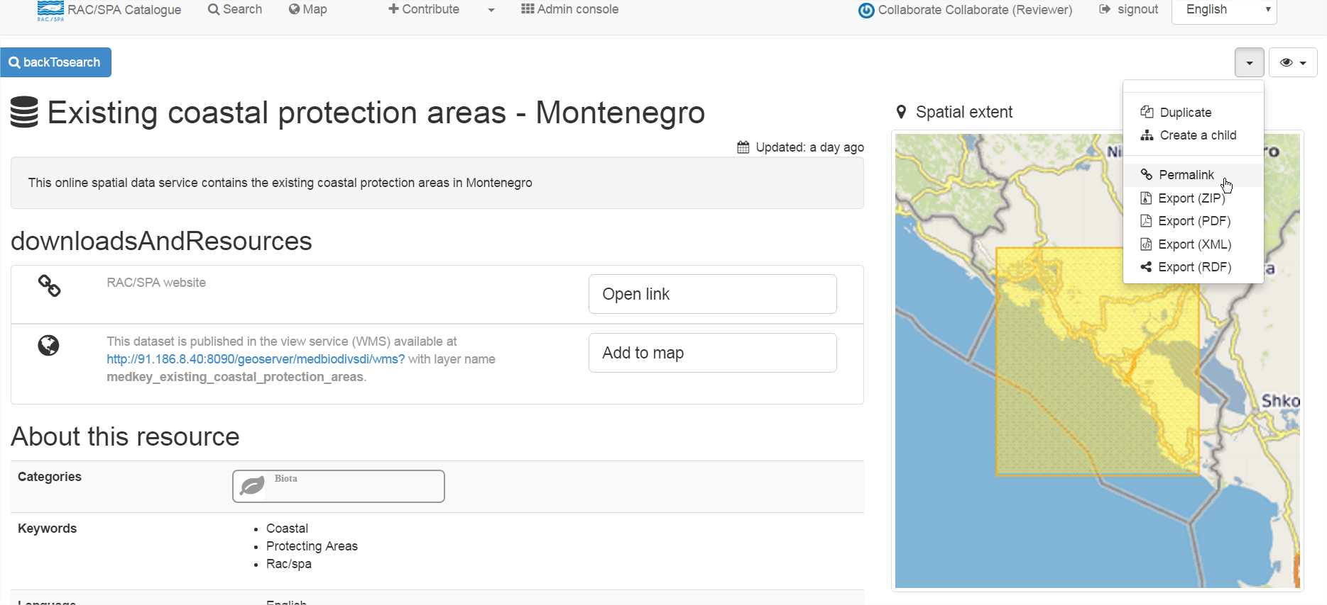

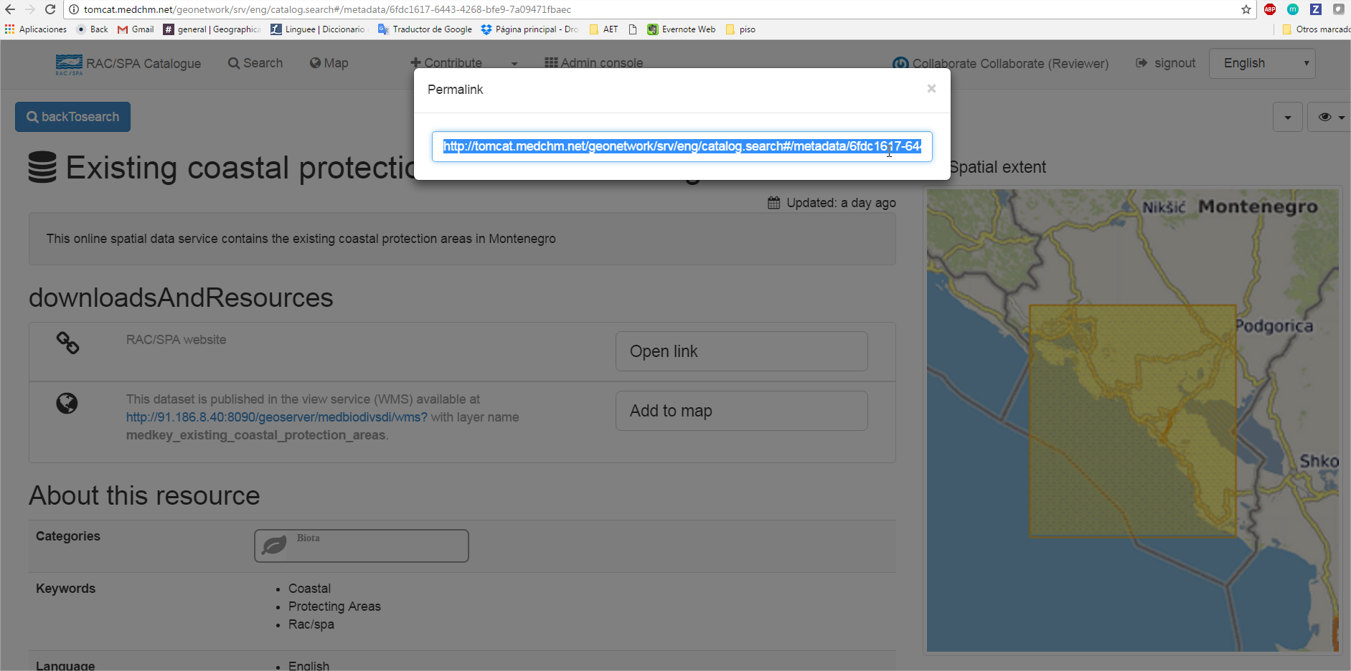

## 

# 04. Geoserver

URL: <http://tomcat.medchm.net/geoserver>

Geoserver is an open source server to publish spatial data according to interoperable standards.

There is complete documentation on how to use Geoserver in this link: <http://docs.geoserver.org/>

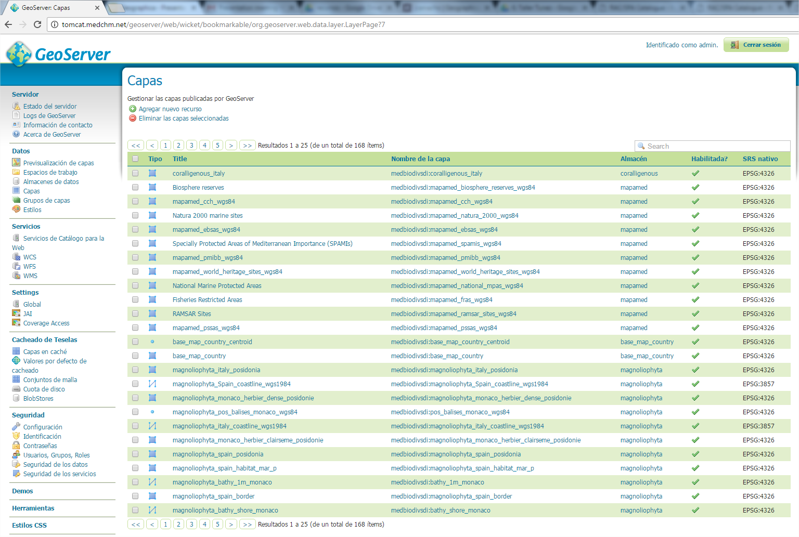

## 4.1 Layer style

To create or edit an existing layer style, Geoserver is based on a SLD system (Styled Layer Descriptor), an OGC standard for WMS styling.

There is complete documentation on SLD possibilities in this link: <http://docs.geoserver.org/stable/en/user/styling/sld/cookbook/>

To easily create new SLD file for layers, we used to use QGIS (<http://www.qgis.org>), that allows to download layer styles as SLD, so you can easily upload it to Geoserver.

### 

### 

### Step 1. QGIS

1. Open a QGIS project
2. Click: Add Postgis LayeR
3. Create a NEW connection that points towards RAC SPA database

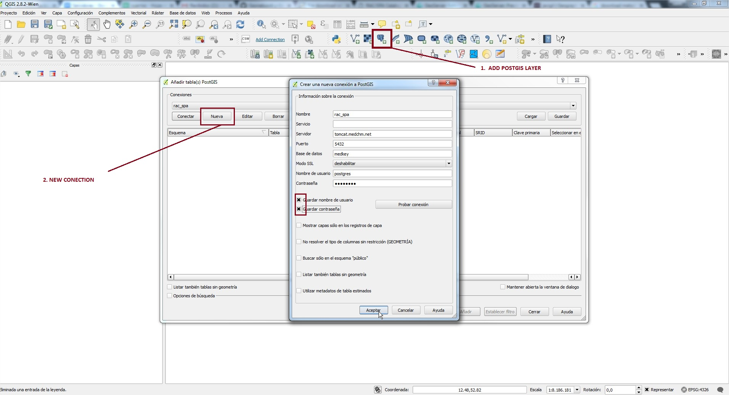

4. Select the Data Base / scheme / table (=layer)

5. Add the layer

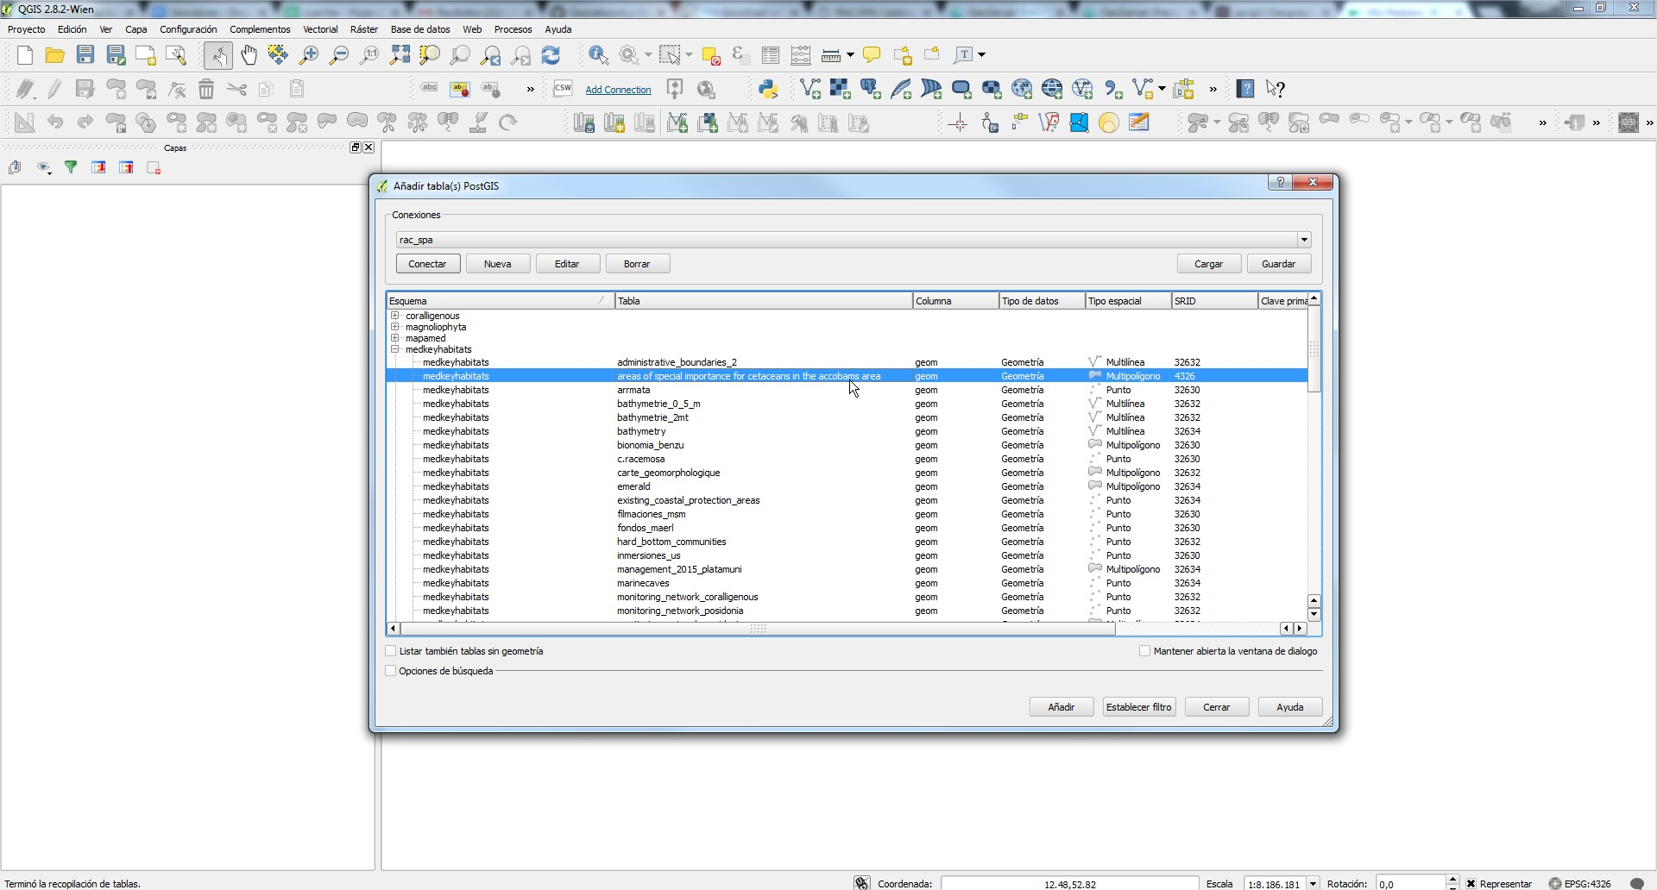

6. Right clic in the layer > Properties

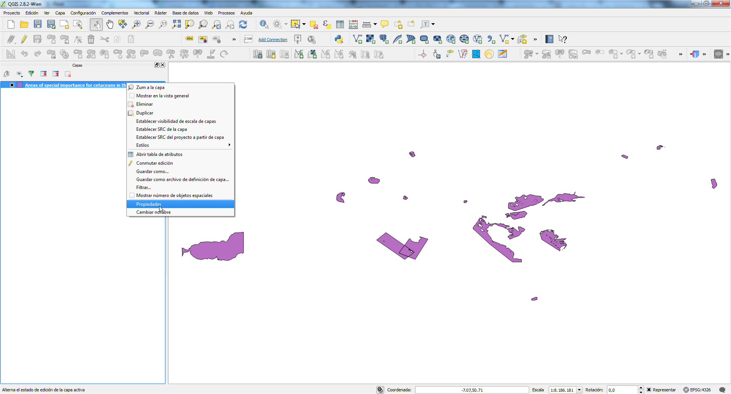

7. Style your layer

For example: Categories from column “name”

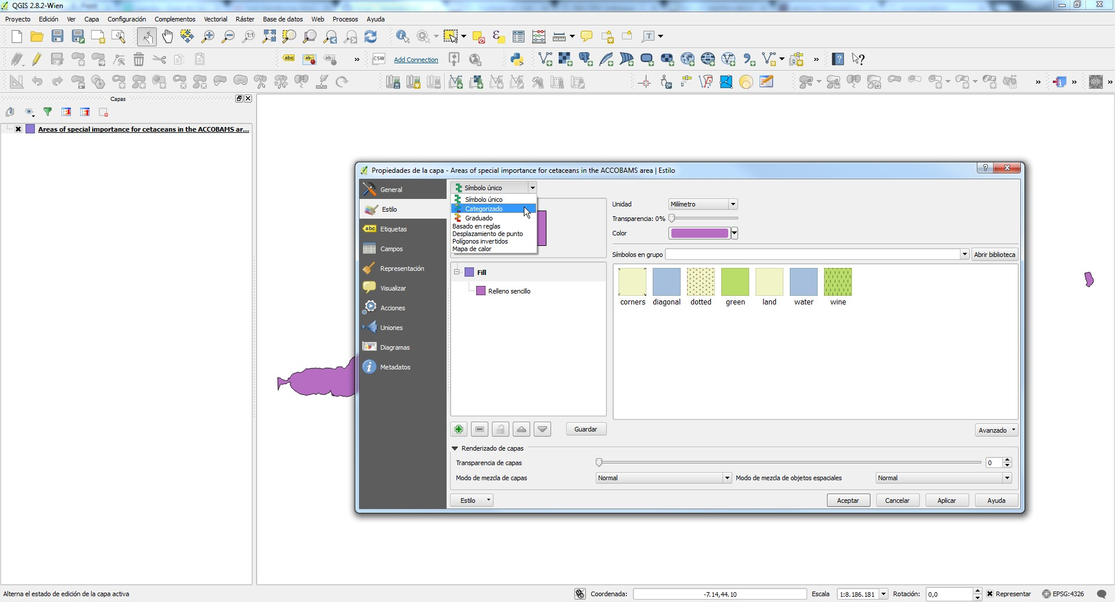

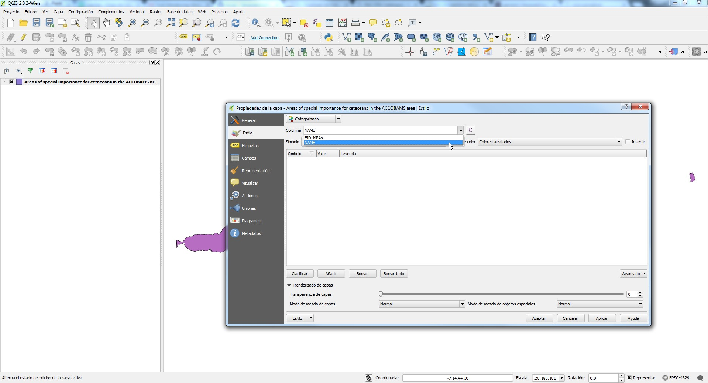

8. Go to Style > Save style > SLD File

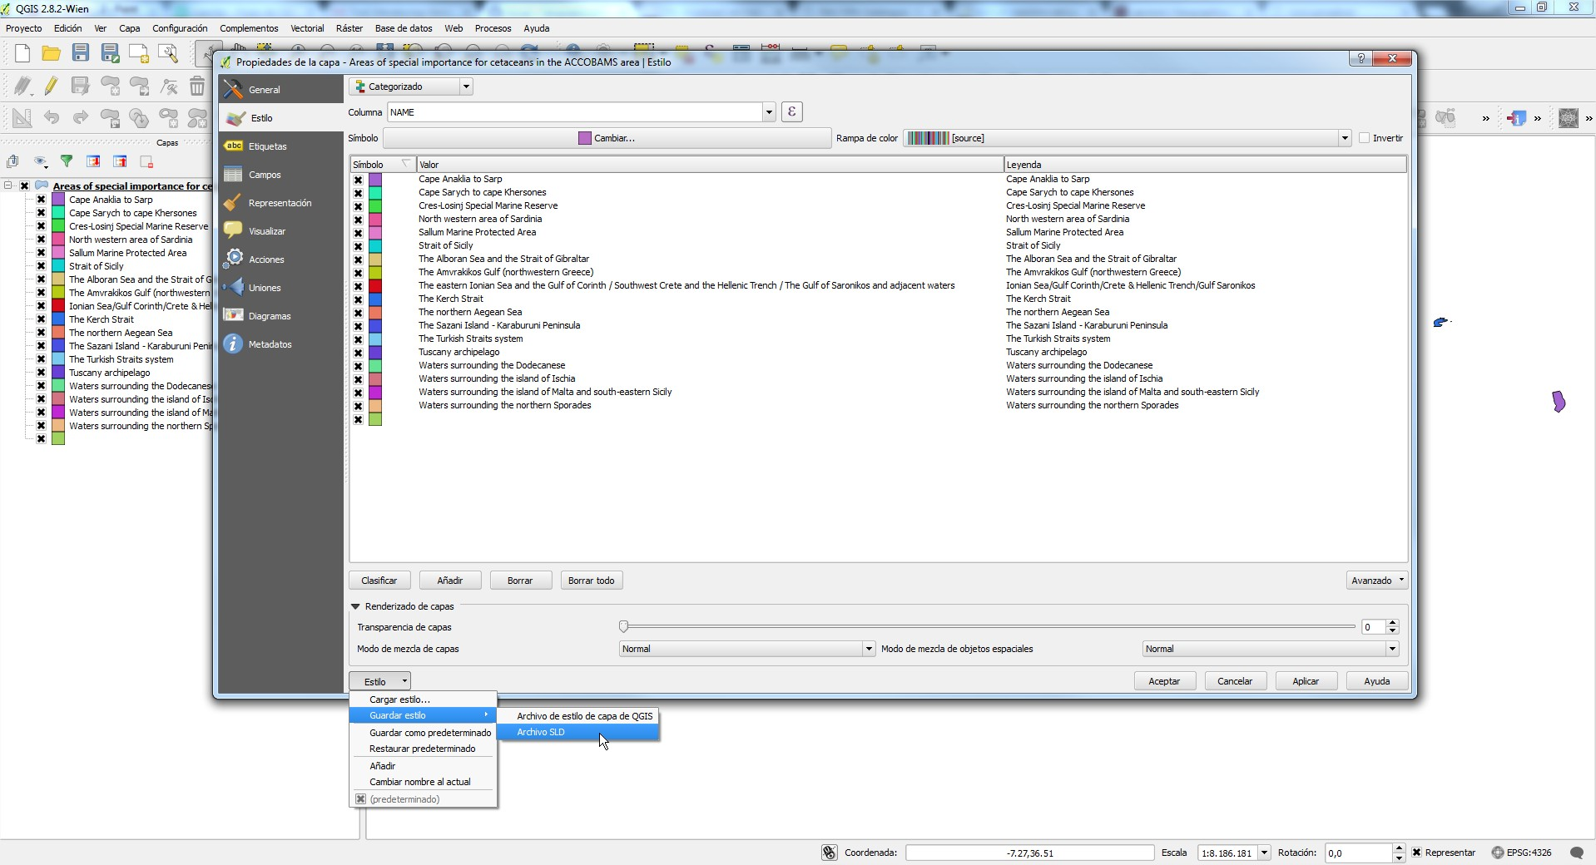

9. You can change the Legend titles to make them shorter. You can do it in QGIS or directly in the SLD (changing <se:Name> and <se:Description> parametre. Do not change <ogc:Literal>).

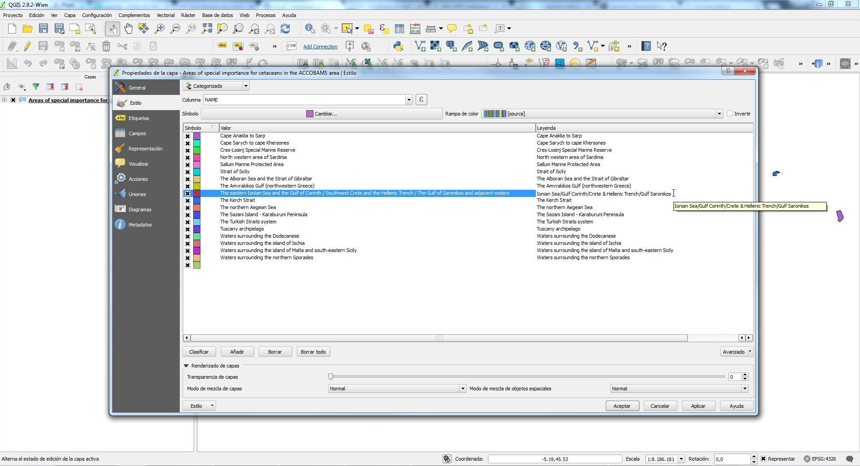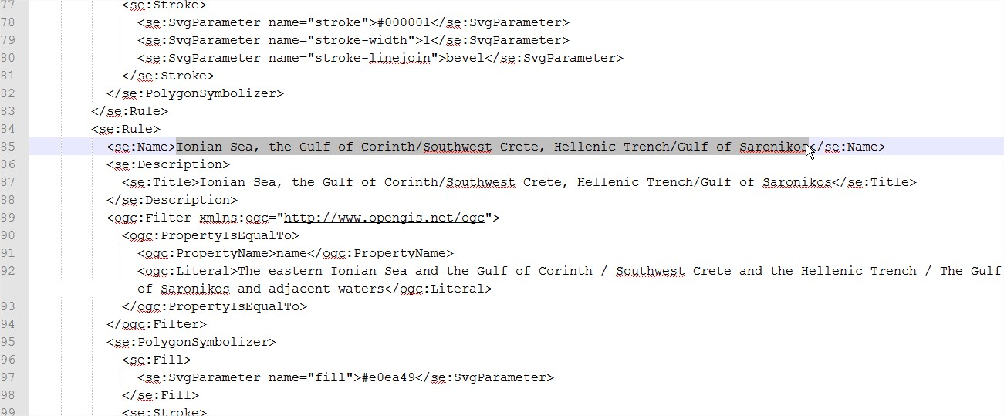

### 

### 

### 

### Step 2. Geoserver

1. Open Geoserver: <http://tomcat.medchm.net/geoserver>

2. Find your layer and Open it.

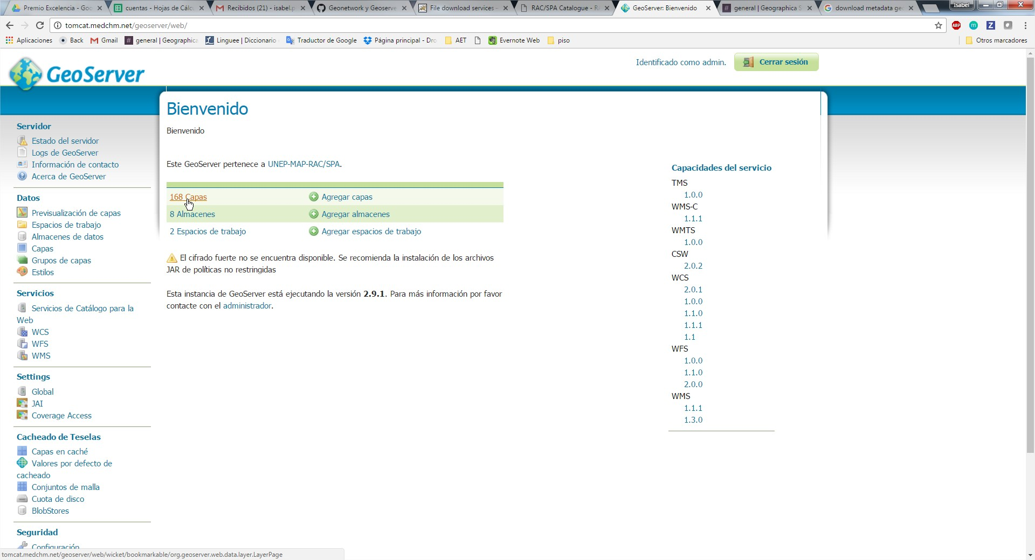

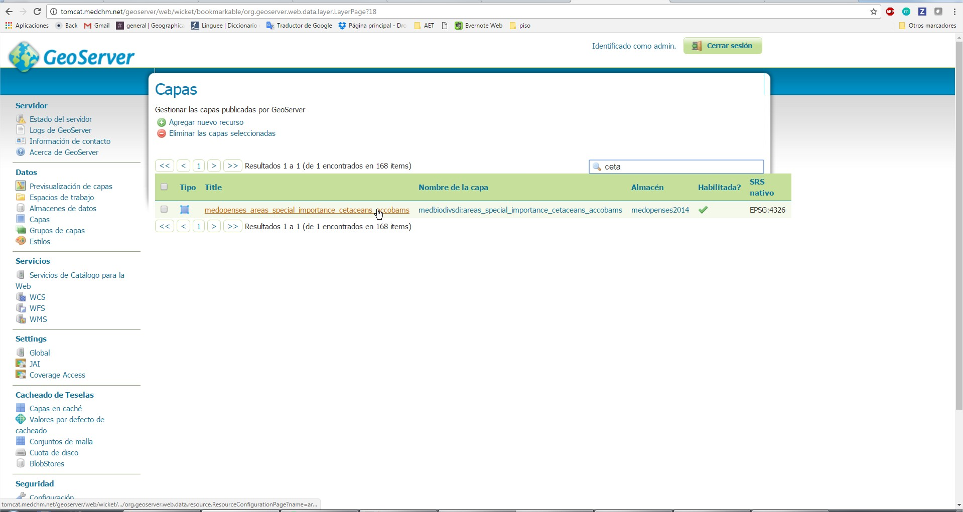

3. Go to “Publication” option and check which is the name of your layer Style.

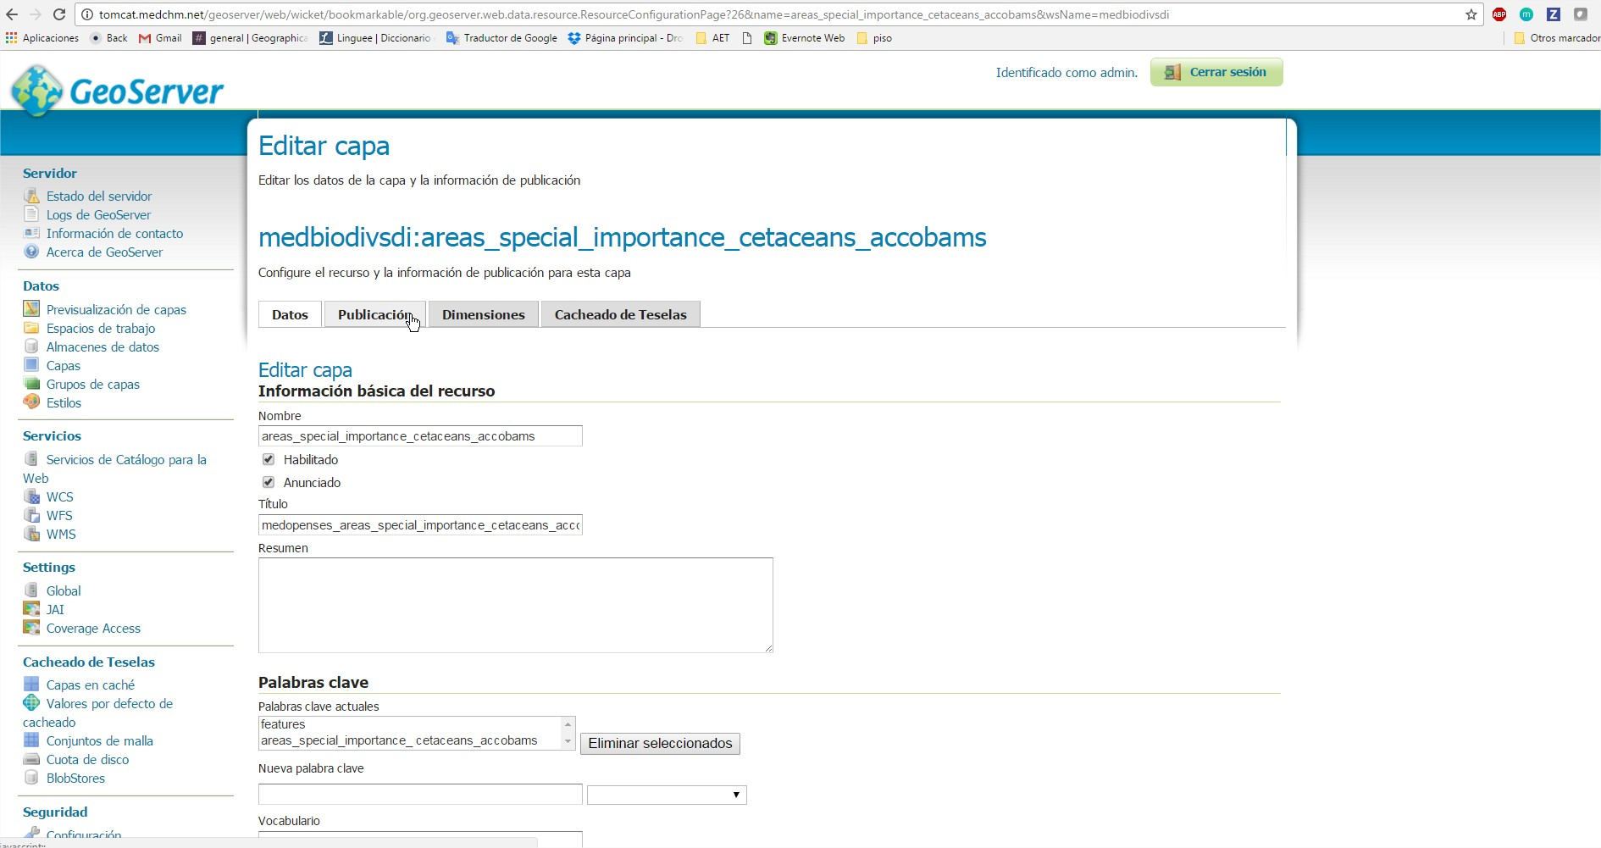

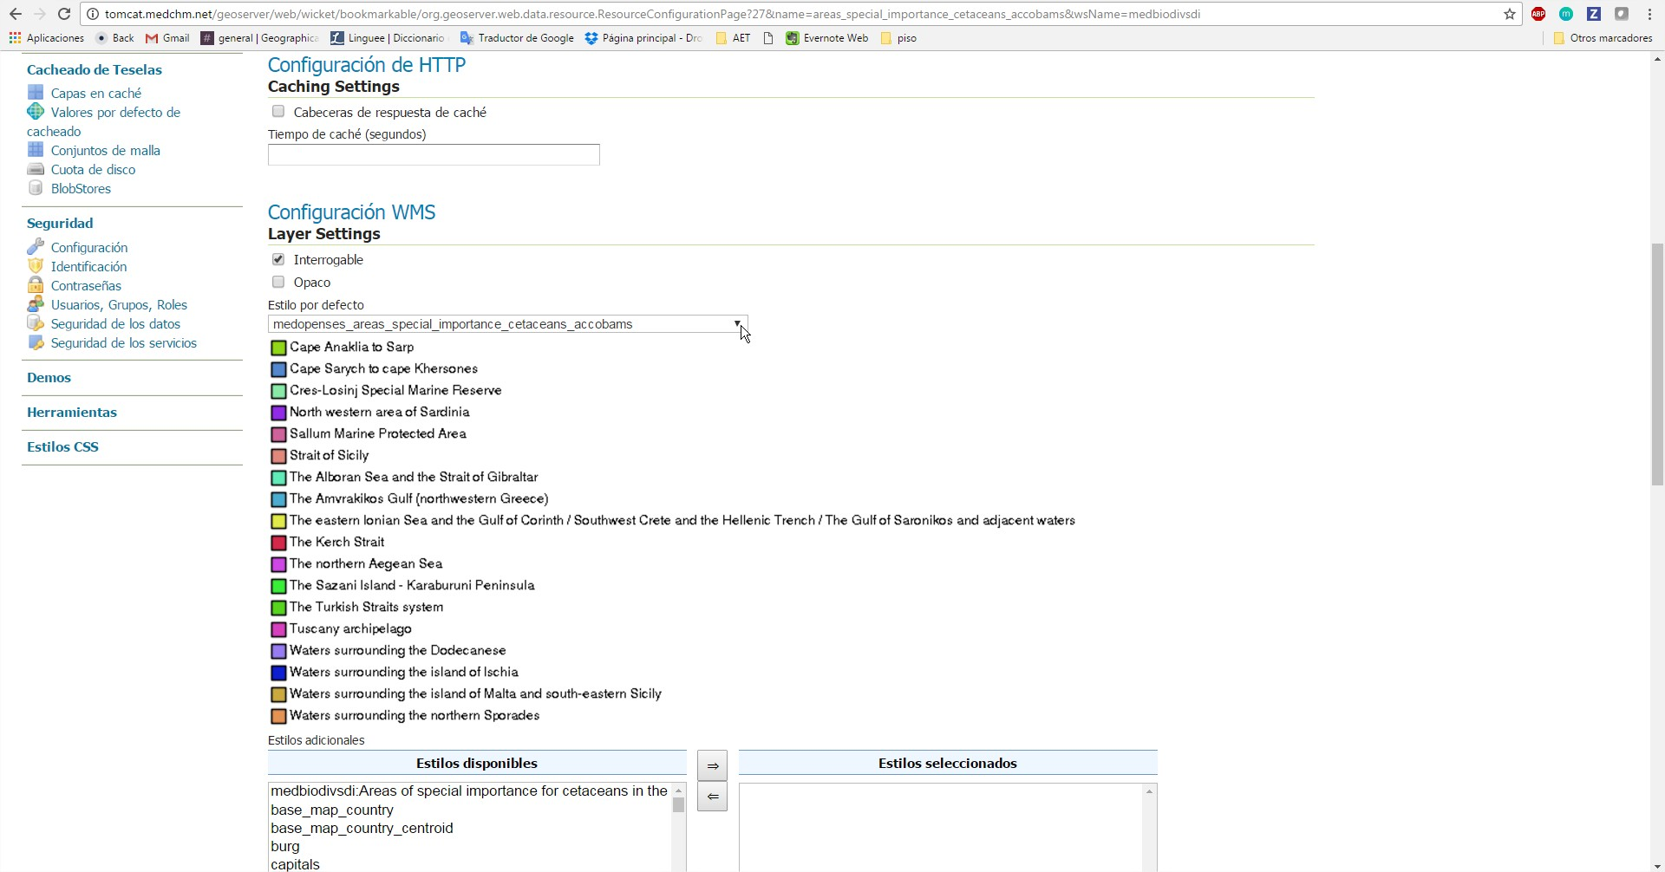

4. Go to the Style menu and find your layer’s style. Open it.

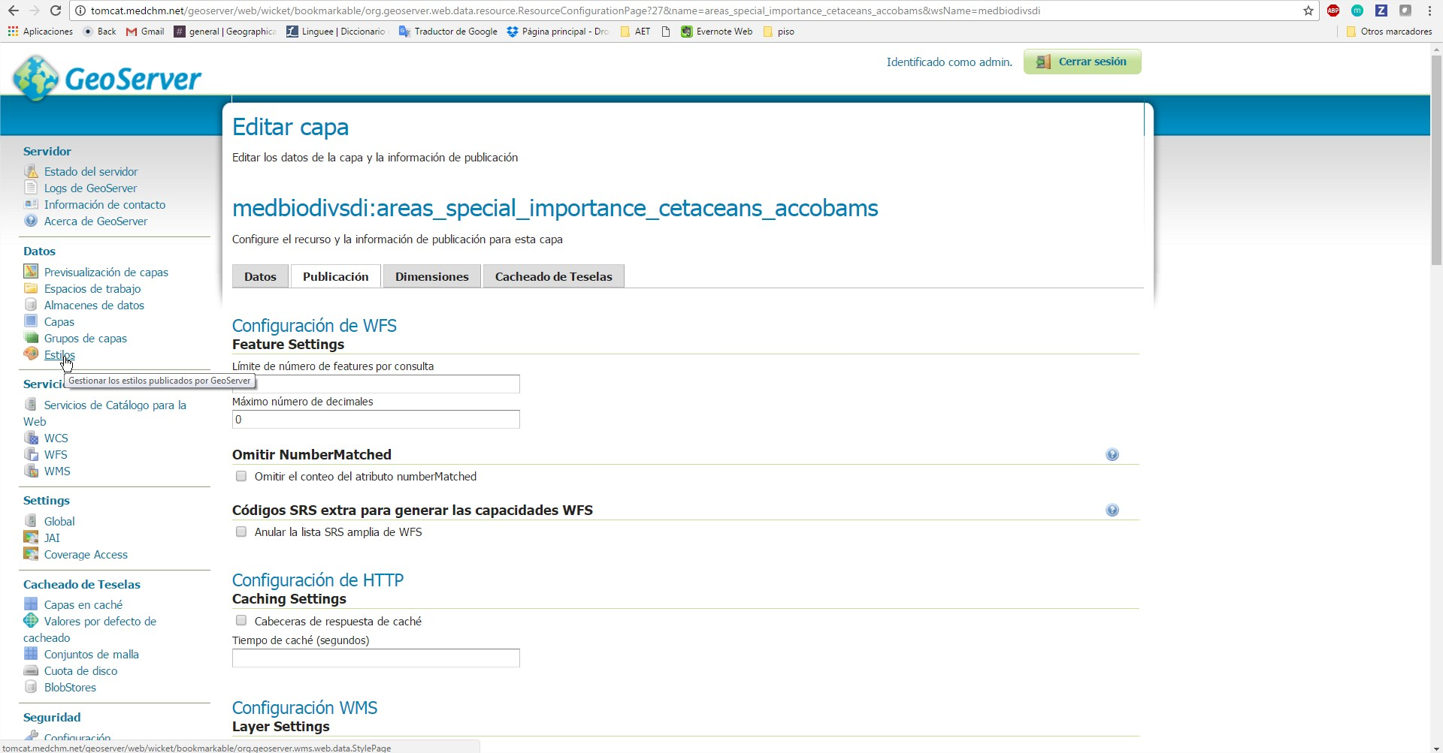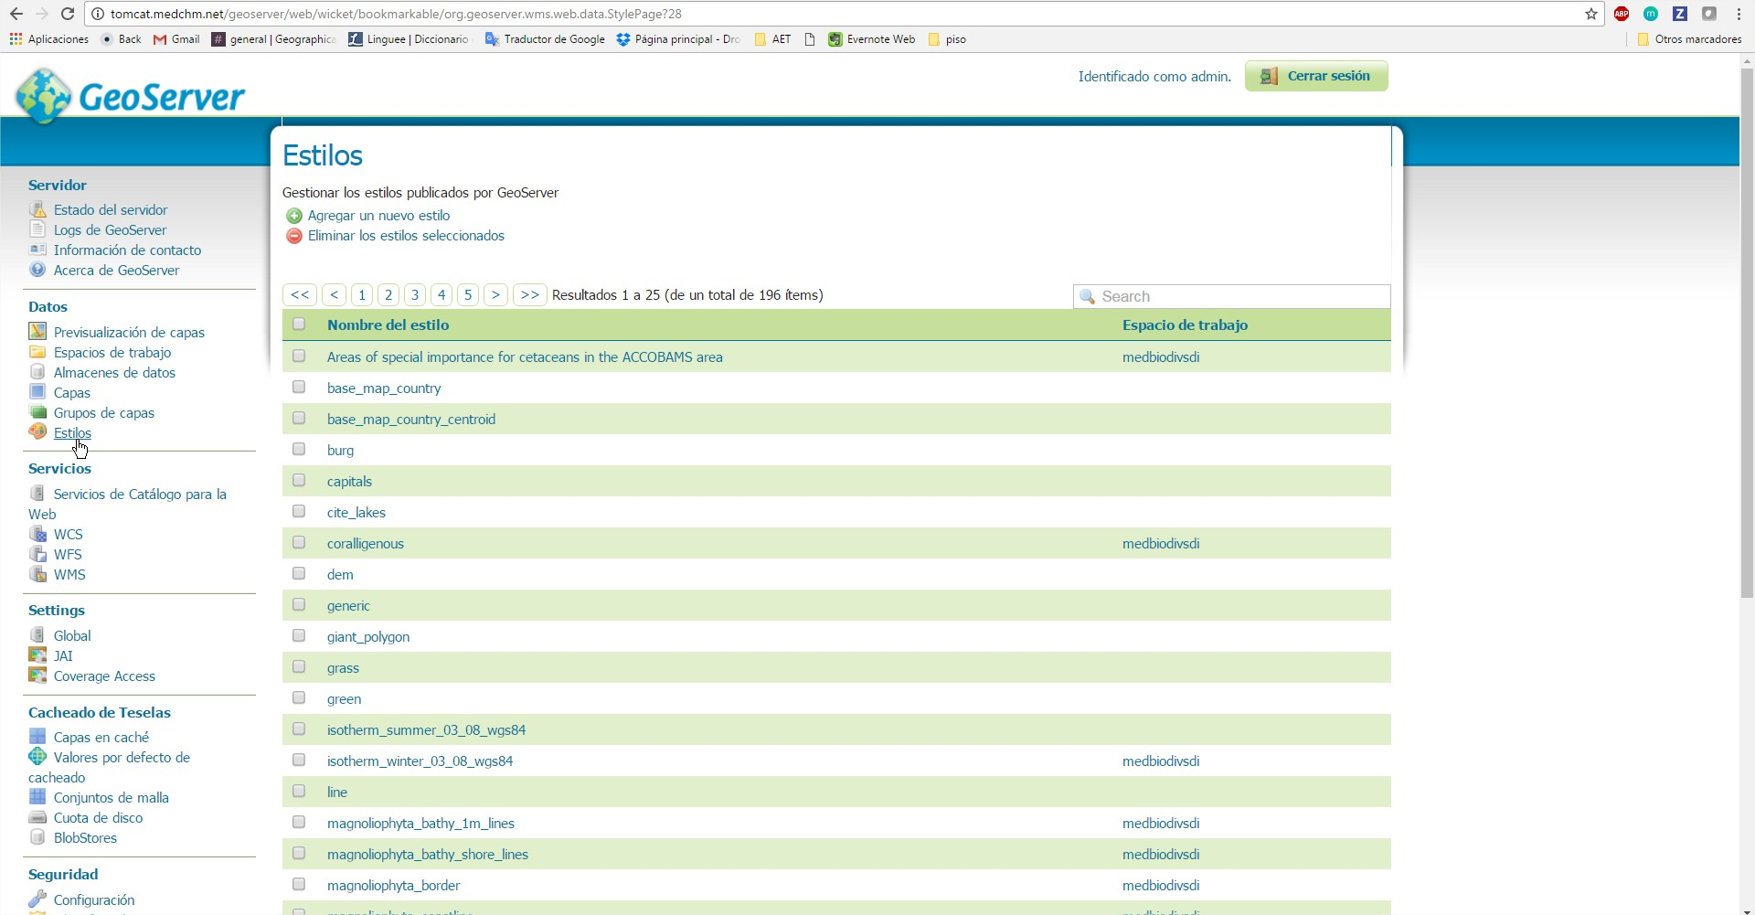

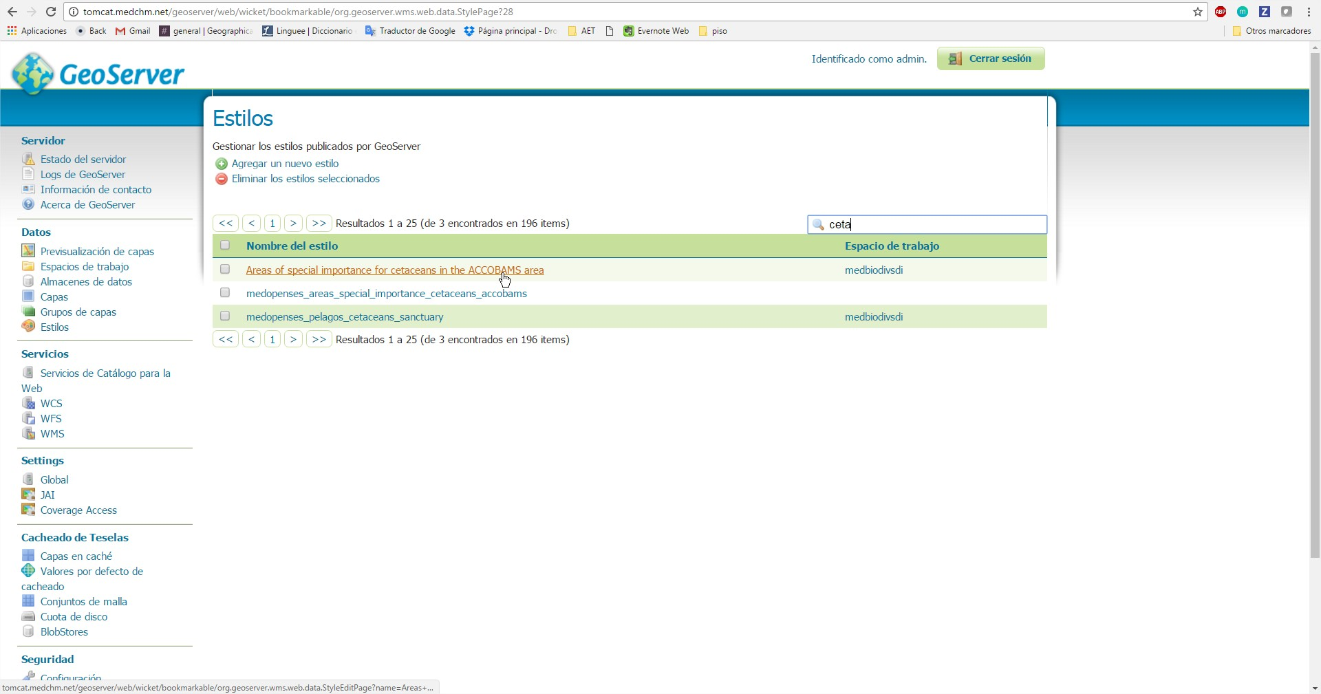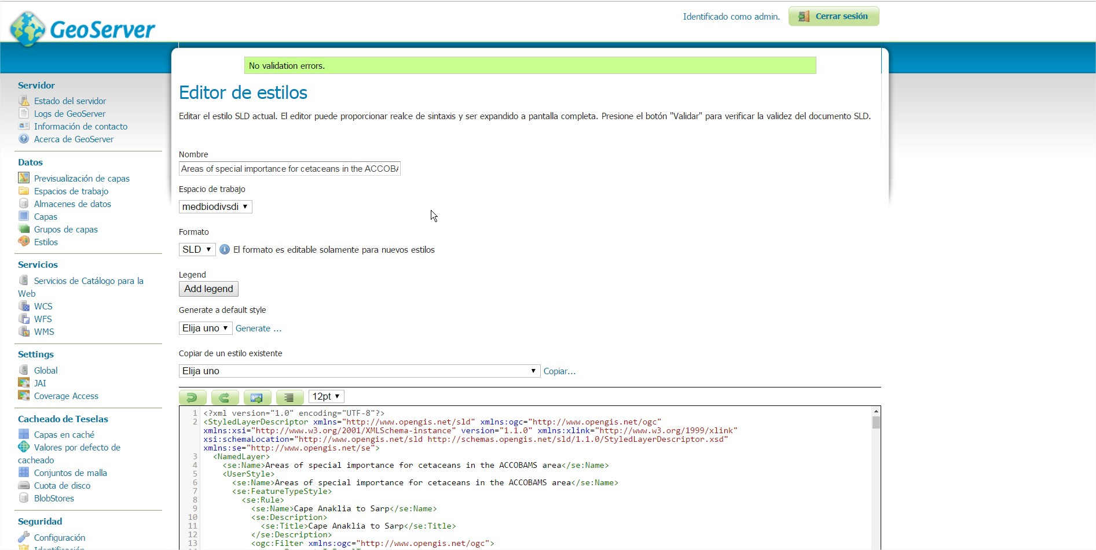

5. To add the new SLD to your layer’s style: click “Select file” and choose the SLD file that we Saved in QGIS in the previous step. Then click “UPLOAD”

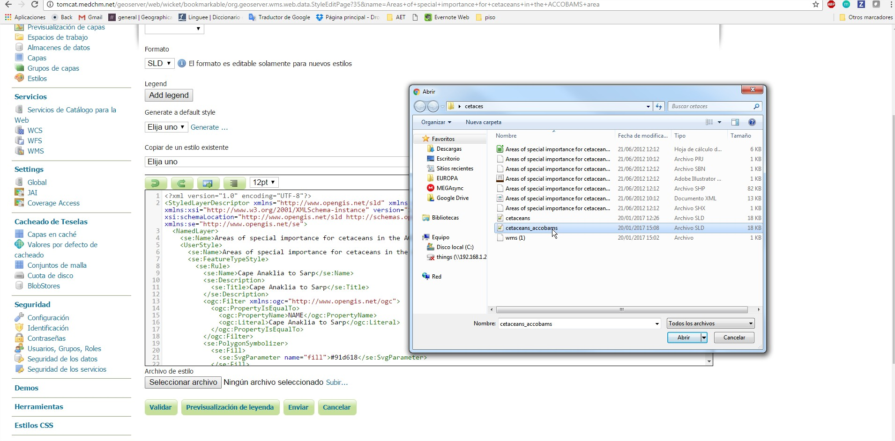

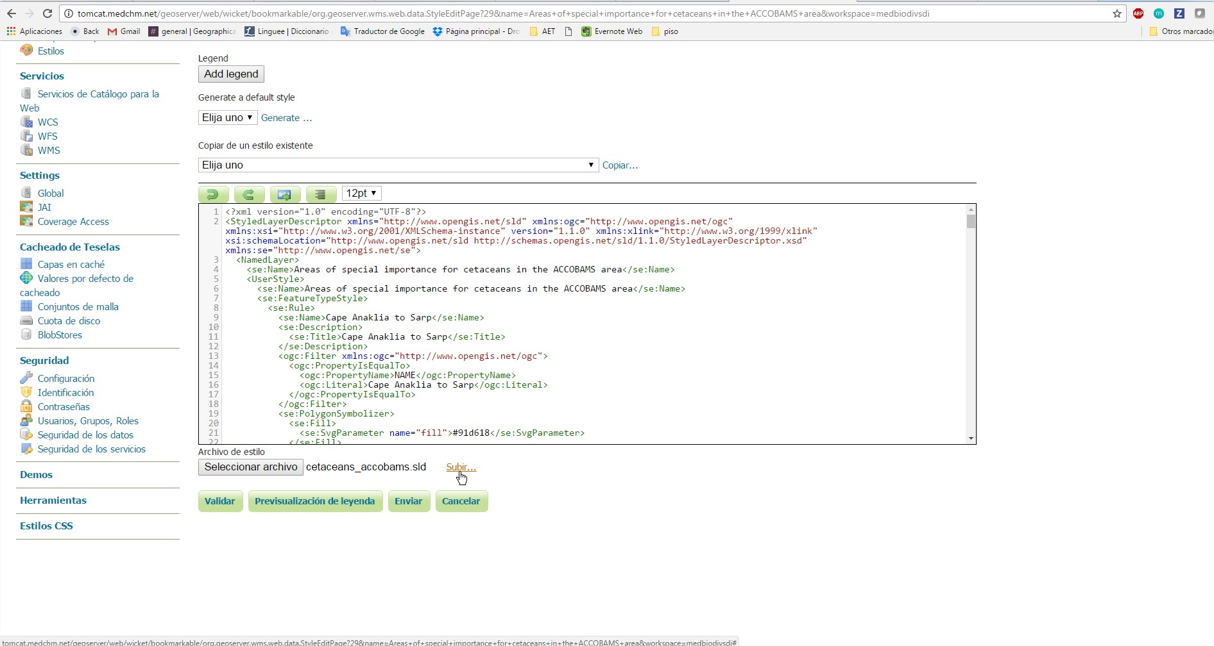

6. Click “Validate” to check if there is any error that you may correct.

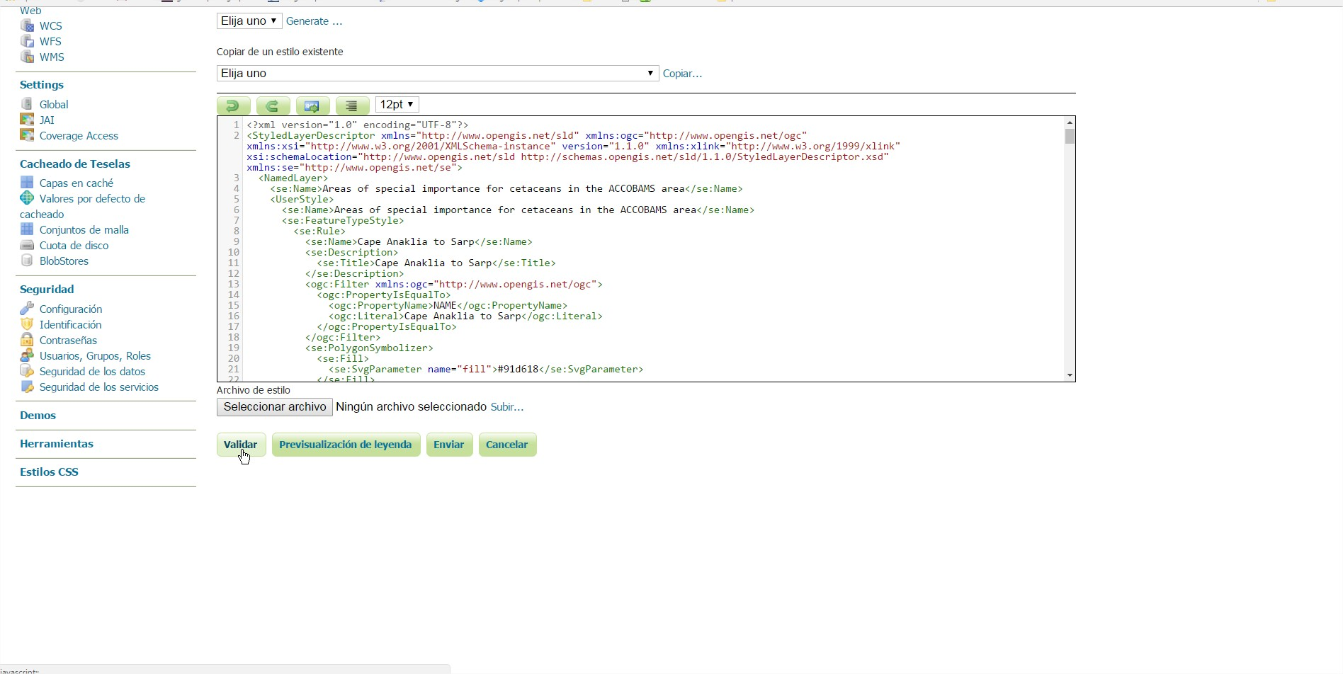

7. Make sure that the Workspace is “medbiodivsdi”. Then click “Send”

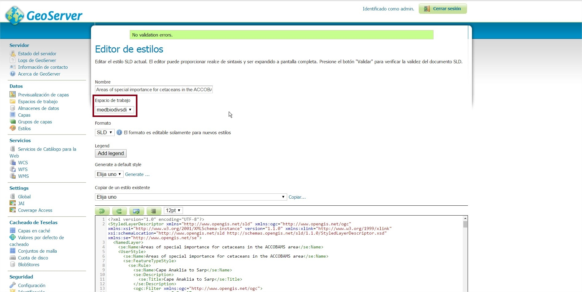

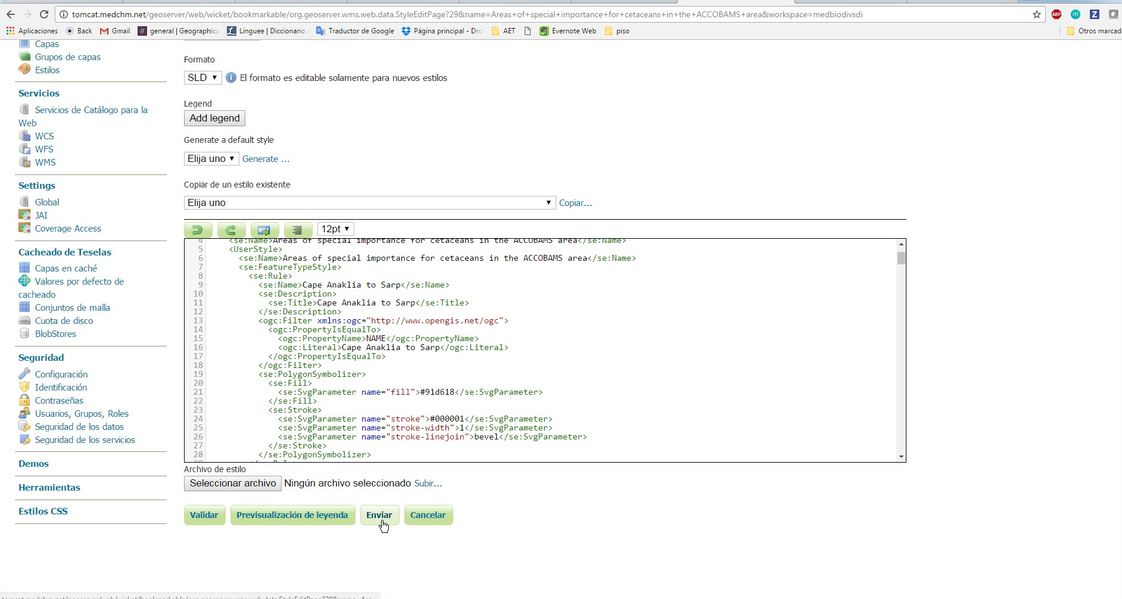

### Step 3. Check if the layer is properly being displayed

1. Go to “Layer preview” and find your layer

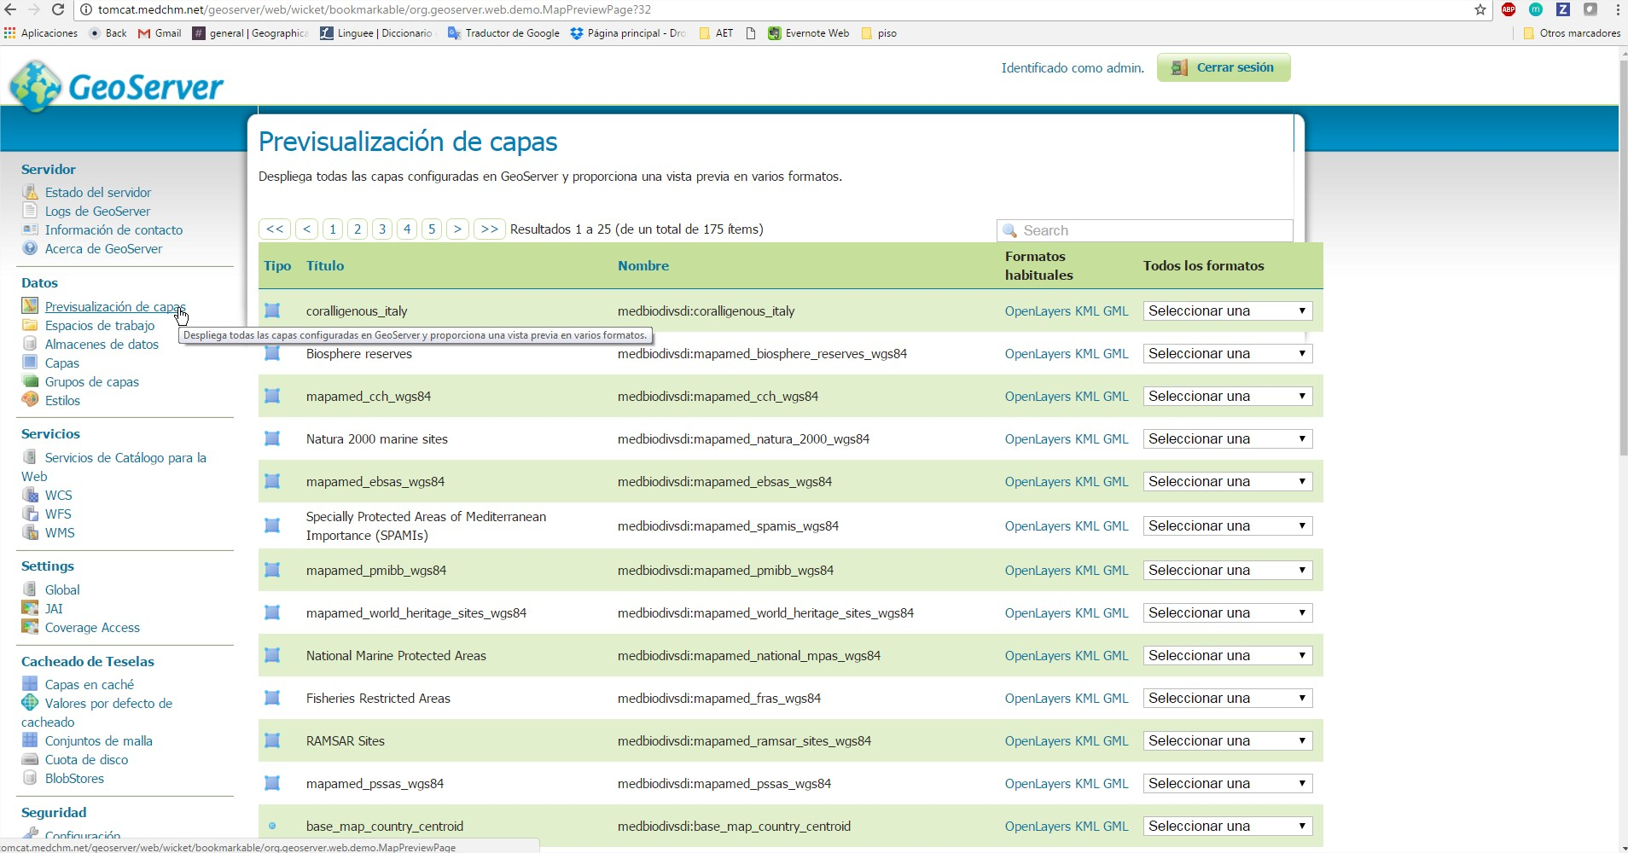

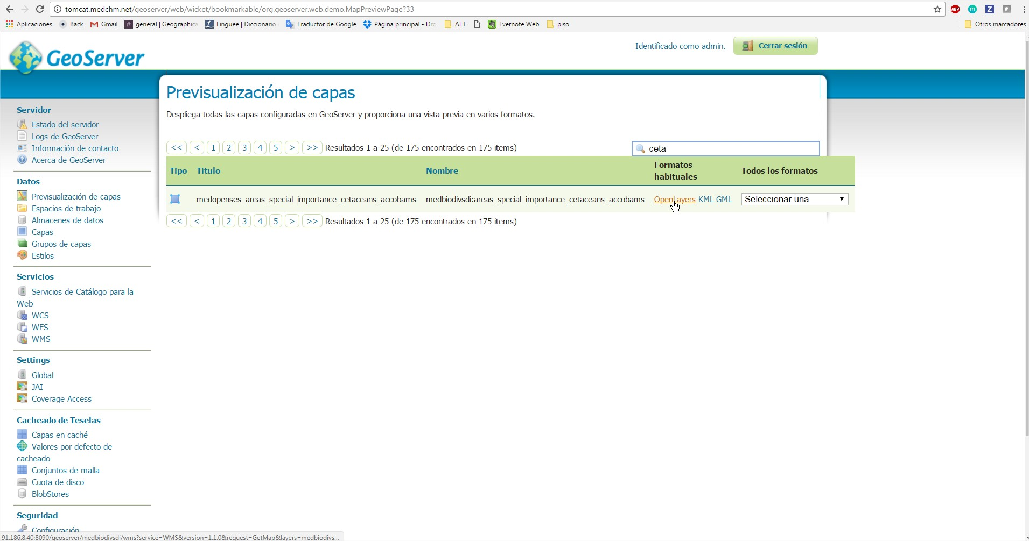

2. Clic “Open Layer” > A frame will be opened to show you your layer. You can clic in the map to get the feature info.

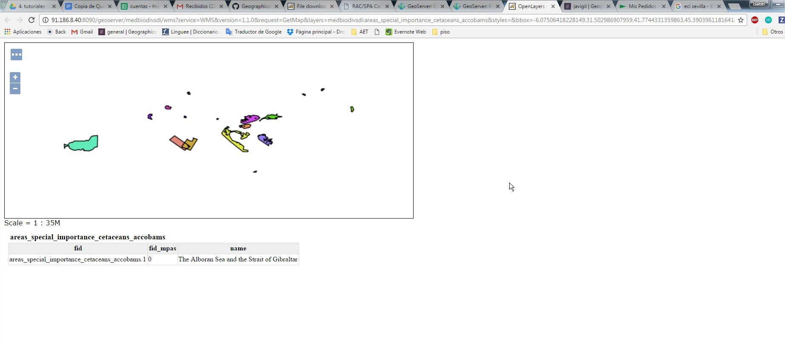

### Step 4. Check in MPB Platform

1. Go to the MPb platform and find your layer in the Catalogue.

2. Add layer

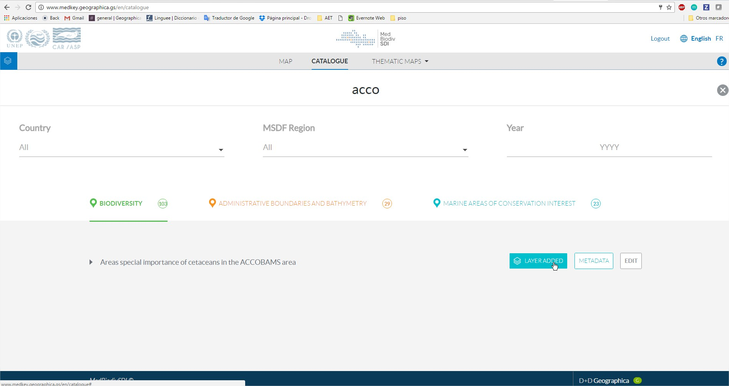

4. Go to the MAP and check if you can visualize your layer

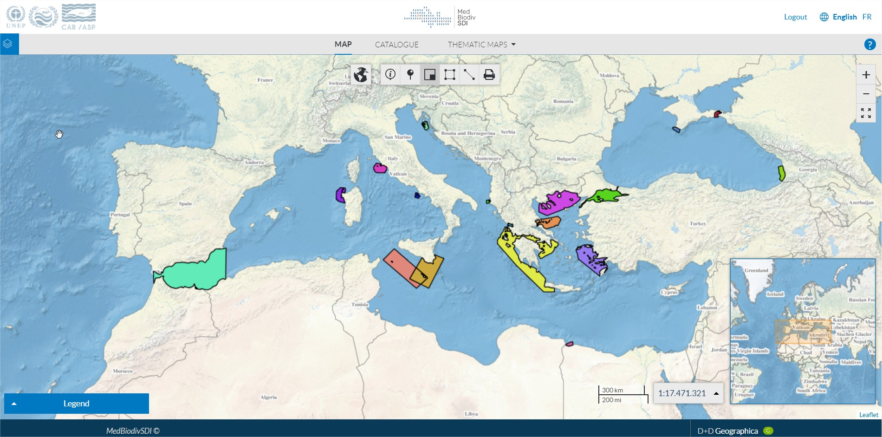

# 05. Data base

MPB database system is based on **PostgreSQL**/**PostGIS**.

<http://postgis.org/>

PostGIS adds support for geographic objects to the PostgreSQL object-relational database. In effect, PostGIS "spatially enables" the PostgreSQL server, allowing it to be used as a backend spatial database for geographic information systems (GIS).

To easily manage and visualize the PostGIS database you can install the desktop programme pgAdmin. pgAdmin is the most popular and feature rich Open Source administration and development platform for PostgreSQL. pgAdmin may be used on Linux, Unix, Mac OS X and Windows to manage PostgreSQL/PostGIS

<https://www.pgadmin.org/>

Mediterranean Platform on Biodiversity is hosted in the **Database** named: “medkey”.

It has 6 schemes where spatial data tables are organized according to the initial layer organization that RAC/SPA had in their server:

1. coralligenous
2. magnoliop`hyta
3. mapamed
4. medkeyhabitats
5. medmpanet
6. medopenses2014

The 7th scheme is named “**public**” and correspond to master system tables that directly affects to MPB content, settings and structure.

**ATTENTION: Please, be very careful on modifying any of these tables, specially those at “public” scheme. Changes are not reversible.**

## 5.1 Categories and topics management

MPB catalogue is structured in 3 main **categories,** that holds N **topics**, that holds N spatial **layers**. The following scheme shows this hierarchy:

1. Categories
   1. Topics
      1. Layers

### Categories

Categories are described in the table: **public.category**

You can edit the name of any category by editing the columns:

* **title_en**: name of the category in MPB English version
* **title_fr**: name of the category in MPB French version

**id** is the identification code for each category. It is used in other tables as foreign key, for example to reference how to organize how each **topic** (child) in each **category** (parent). And after in the layers’ table to organize how each **layer** is organized inside one topic. You may not edit this code.

Categories in MPB:



Categories table overview:

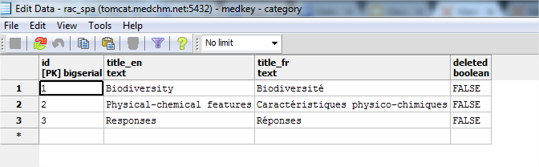

### 

### 

### Topics

Topics are described in the table: **public.topic**. It main columns are:

* **id:** is the identification code for each topic. It is used in other tables as foreign key. You may not edit this code.  
  **title_en:** name of the topic in MPB English version. You can edit it to change the label in the MPB platform.  
  **title_fr text:** name of the topic in MPB French version. You can edit it to change the label in the MPB platform.  
  **category_id:** Foreign key to the public.category table. If you want a Topic to be held in other category, for example, if you want to change the topic “Bathymetry” from “Pysichal-chemical features” category to “Responses” you can edit the category_id column and change category_id=2 for category_id = 3.

Topics in MPB:  
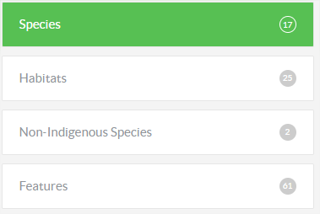

Categories table overview:  
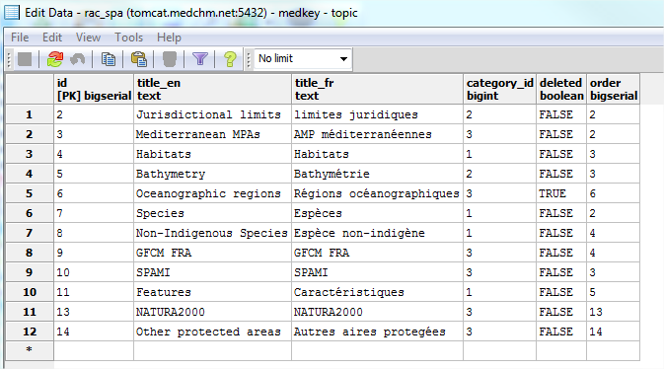

## 5.2 Layers management

Topics are described in the table: **public.layer**. Most layers information can be directly changed in the MPB layer’s form.

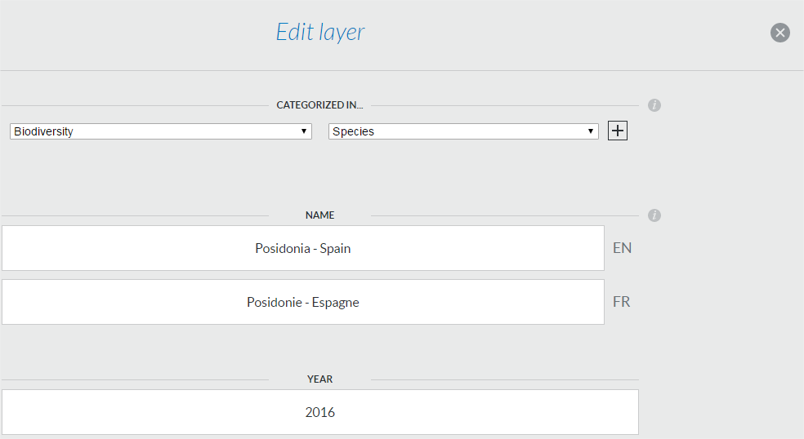

It main columns are:

* **id:**  is the identification code for each layer. It is used in other tables as foreign key. You may not edit this code.
* **title_en:** name of the layer in MPB English version. You can edit it to change the name of the layer.
* **title_fr:** name of the layer in MPB French version. You can edit it to change the name of the layer.
* **wms_server:** link to a wms server.
* **wms_layer_name:** name of the layer from the wms server that want to be published.
* **geonetwork:** Link to layer's metadata
* **desc_en:** Layer’s description in English.
* **desc_fr:** Layer’s description in French.
* **datasource:** Name of the responsible organization in charge of this layer
* **topic_id:** Topic in which each layer is held. It is Foreign key to the public.topic table.
* **deleted:** TRUE/FALSE. When a layer has been removed from the MPB catalogue it is in a “invisible” mode (TRUE), so it isn’t actually deleted from the database. If you want to recover an “invisible” layer, for example, if it has been removed by error, you can change the value from TRUE to FALSE, so it will be published again in the MPB.
* **order:** order of layer’s list.
* **country:** country code, It is foreign key of table **public.country**
* **year:** layer’s year.
* **msdf**: name of msdf region. It is foreign key of table **public.msdf**
* **username**: name of the user that has uploaded the layer.

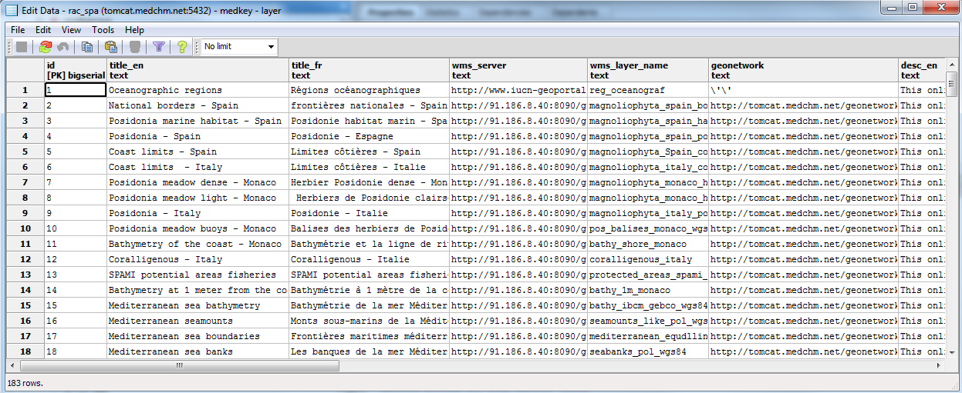

## 

## 

## 

## 5.3 Other dictionaries managements

### Countries

The list of countries of the layer’s form is on the table **public.country**

## 

You can include a new country or edit an existing one label by editing this table. Main columns are:

* **id_country:**  is the identification code for each country. It is used in other tables as foreign key. You may not edit this code.
* **name_en:** name of the country in English.
* **name_fr:** name of the country in French.

### MSDF region

The list of MSDF regions of the layer’s form is on the table **public.msdf**

You can add new MSDF regions directly at the Layer’s form. If you want to change the name of an existing one, you can do it in the data base table.

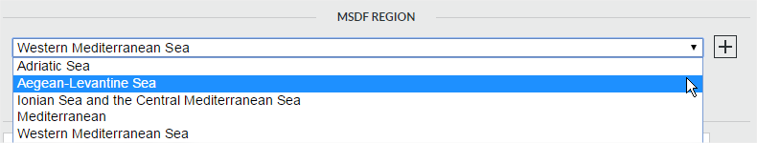

Colums:

* **gid:** is the identification code for each MSDF region. It is used in other tables as foreign key. You may not edit this code.
* **name_en:** name of the region in English.
* **name_fr:** name of the region in French.

## 5.3 Thematic maps management

Scheme: public  
Table: **layer_configuration**

**column: data**

* First part of the code is layer id from table layer: you can include all the layers that you want to show in the thematic map in order of apearance.  
  **160_165_161_162_164_163_159_167_158_168_166**/1_1_0_0_1_1_1_0_1_1_0/80_80_80_80_80_80_80_100_100_70_80
* Second part of the code is if each layer would be visible or not by default in the map.   
  1 = visible  
  0 = not visible  
    
  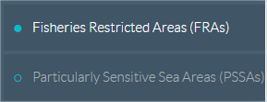  
    
  160_165_161_162_164_163_159_167_158_168_166/**1_1_0_0_1_1_1_0_1_1_0**/80_80_80_80_80_80_80_100_100_70_80
* Third part of the code is layer opacity from 0% to 100%  
  160_165_161_162_164_163_159_167_158_168_166/1_1_0_0_1_1_1_0_1_1_0/**80_80_80_80_80_80_80_100_100_70_80**

**column: title_en**

* Name of thematic map in english.

**column: title_fr**

* Name of thematic map in french.

With this instructions you would be able to edit existing thematic maps, create a new one or delete them (by deleting it row from the layer_configuration table). This changes are not reversing.

## 5.4 Update static pages information

All static html application code is in $PROJECT_HOME/www/src/js/template. If you make any changes to these files you must recompile the frontend following **Step 2. recompile code once you change translations.** After you compile the application, the corresponding static files are generated for all languages and are stored in $PROJECT_HOME/www/cdn/fr/ or $PROJECT_HOME/www/cdn/es/

**ATTENTION:** Files in $PROJECT_HOME/www/cdn should never be modified manually because you will lose the changes after each compilation.

All the translatable text is between **<lang></lang>** tag. When you compile frontend, the application searches for all the text contained in this tag in the **key** column of the **public.translations** table from the PostGIS database. If it finds the key, it replaces the text of the tag with its corresponding language. If not, it adds a new record to the database that must be translated as follows and recompile the frontend again.

All the translatable text of the platform are defined in the **public.translations** table from the PostGIS database.

**ATTENTION**: this table is one of the system master tables, so, you could break the system modifying that table. Geographica would decline responsibility for the system broken if RAC/SPA or any third parties change the data of master system tables, because no backup is being done from Geographica’s part, as we are not responsible of the server maintenance.

There are three columns:

* **key**: ATTENTION. Do not modify this column data because you may break something in the platform. Source code look for this key position to show a text’ label in the platform in both languages. Even if you want to completely change the text at **en** | **fr** columns, and it does nothing to do with the key text, do not change key label.
* **en**: Text translation in english. You can edit the text of this column, but it will not be updated automatically in the platform, you have to follow **Step 2. recompile code once you change translations** to update text translations in the platform.
* **fr:** Text translation in french. You can edit the text of this column, but it will not be updated automatically in the platform, you have to follow **Step 2. recompile code once you change translations** to update text translations in the platform.

For example: if you want to modify the text of this button from “NEW LAYER” to “CREATE A LAYER”.



You have to follow the following steps:

**Step 1. Change translation in the database**

You have to go to the **public.translation** table and look at the **key** column for the label “New layer”:

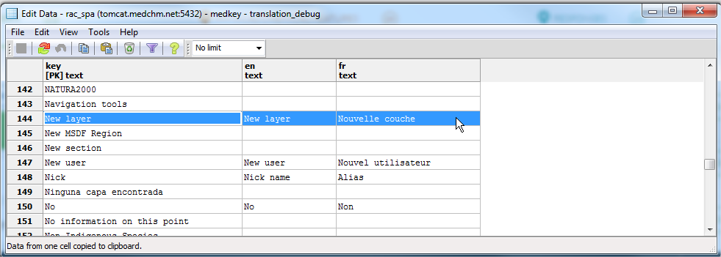

Once you have found the label, you can change the “**en”** and “**fr”** columns. Remember to **do not** change the “key” column.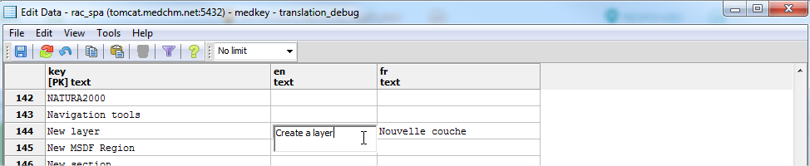



**Step 2. Recompile code once you change translations**

Once you change something in translation table, a recompile of frontend code should be done. The code is build using a runtime built called NODE.JS, and it has to be recompiled to flat HTML, Javascript and CSS files. To do that, you have to open a terminal in the server, go to $PROJECT_HOME/www/src, and run 'node build.js'.

### 

# 

# 

# 06. Server

## 6.1 Application structure

/var/www/vhosts/[medchm.net/data.medchm.net/web](http://medchm.net/data.medchm.net/web) where the project is kept, so from now, it will be called $PROJECT_HOME.

In $PROJECT_HOME there are two folders:

* www - is the frontend part of the code, to be easier to understand, it is the part of the code that shows things (html, css, javascript) to the client. The compilation of the frontend is explained in section 5.6
* API - is the backend part (Using python framework called Flask), that's the part of the application that manages database connection, calculations, and business logic.

## 6.2 Config files

The application contains three configuration files:

* Config.js: It’s located in $PROJECT_HOME/www/src/js. It’s a json file with two keys.
  + API_URL: It indicates the domain of the backend, for example <http://data.medchm.net/api>. The following sections explain how to start the backend and the server configuration.
  + BASE_PATH: It’s used if application root domain contains a path. In normal case must be empty string.
* config.py: It’s located in $PROJECT_HOME/var/www/vhosts/medchm.net/data.medchm.net/web/api/api. It’s a python file composed of the following keys:
  + baseRootPath: It’s the root path of the application, for example /var/www/vhosts/medchm.net/data.medchm.net/web
  + geoserver_apirest: The domain where the Geoserver app is located, for example http://tomcat.medchm.net/geoserver/rest
  + geoserver_user: Geoserver admin user.
  + geoserver_psswd: Geoserver admin password
  + geoserver_ws: Geoserver workspace.

**ATTENTION:** Any other values in the config.py file should be modified

* config.py: It’s located in $PROJECT_HOME/api/model/base/PostgreSQL. This python file contains the information necessary for the application to connect to the database.

## 6.3 Deploy backend

Deploy instructions to run the project on the server, from the terminal, it's necessary to follow the next steps:

1. Go to $PROJECT_HOME/api, and there is a script called uwsgi.bash. You can run it in the current terminal, but it will block your actual terminal, and if you close it, it will be shutted down. So the best way to run it is using screen.
2. Screen is a tool that allows us to create different threads in our system to execute some different processes in parallel. **ATTENTION!** Two different threads with our server shouldn't never be executed at the same time.
3. Just a very basic commands to use screen:
   1. screen - it opens a screen session, for you it will be like if you open a new terminal session.
   2. screen -r in our server, that we just have one session, it will open our current screen with our project being ran.
   3. screen -ls to check which screen sessions are being executed in that system.
   4. screen -r sessionid, opens the session screen with that id.
   5. If you want to kill a screen session, you have to connect to that session, and press ctrl + a and then a capital K and press y.
   6. If you want to close the session, and it is blocked with the execution of the project, just press ctrl(PC)/cmd(MAC) + a + d.
4. So if you want to run the server, just open a new screen (screen), go to $PROJECT_HOME/API and then run the script uwsgi.bash. Then close the session using ctr + a + d.

**The backend will be start to 5001 port.**

## 6.4 Server configuration

The application can be deployed on an Apache or Nginx server.

The server root path must be $PROJECT_HOME/www/cdn/

You must configure two proxy pass

* Proxy to Geoserver: The geoserver domain must point to /geoserver, for example:

ProxyPass /geoserver http://91.186.8.40:8090/geoserver

* Proxy to backend. The backend domain must point to /api. In section 6.3 we started the backend in 5001 port so the proxy could be:

ProxyPass /api http://127.0.0.1:5001

If the proxies are configured correctly your domain/geoserver (http://data.medchm.net/geoserver) should show the Geoserver main page and your domain/api (http://data.medchm.net/api) should show this message:

{  
 "status": "running"  
}

In this example, the **API_URL** valuefrom config.js must be <http://data.medchm.net/api> (see section 6.2)